SUBCOURSE EDITION
FI0175 A

DETERMINING ENTITLEMENTS, PART I



DETERMINING ENTITLEMENTS, PART I

Subcourse Number FI0175

EDITION A

United States Army Soldier Support Institute
Fort Jackson, South Carolina 29207-7045

5 Credit Hours

Edition Date: June 1993

SUBCOURSE OVERVIEW

This subcourse presents the basic procedures involved in the certification of allowance applications and determining entitlement to allowances.

There are no prerequisites for this subcourse.

This subcourse reflects the doctrine which was current at the time it was prepared. In your own work situation, always refer to the latest official publications.

Unless otherwise stated, the masculine gender of singular pronouns is used to refer to both men and women.

Terminal Learning Objective

Action: You will determine entitlements, compute rates, and identify substantiating documents for subsistence and housing allowances.

Condition: You will be given information from and extracts of the Department of Defense Pay and Allowance Entitlement Manual (DODPM), the Joint Federal Travel Regulation (JFTR), AR 37-104-3, AR 3a-104-4 (Draft), and the Automated Data Systems Manual (ADSM).

Standard: To demonstrate competency of this task, you must achieve a minimum of 70% on the subcourse examination.

i FI0175
TABLE OF CONTENTS

Section Page

Subcourse Overview i

Lesson: Entitlement to Allowances 1-1

Part A: Basic Allowance for
Subsistence 1-2

Part B: Basic Allowance for Quarters 1-16

Part C: Family Separation Allowance 1-34

Part D: Variable Housing Allowance 1-45

Practice Exercise 1-63

Answer Key and Feedback 1-67

Appendix A: Extract from DODPM A-1

Appendix B: Extract from VHA Tables B-1

Use the above publication extracts to take this subcourse. At the time we wrote this subcourse, these were the current publications. In your own work situation, always refer to the latest official publications.

FI0175 ii
LESSON

ENTITLEMENT TO ALLOWANCES

MQS Task: 01-0204.00-0009
STP Task: 14-73C-121-008-1481

OVERVIEW

Lesson Description

In this lesson you will learn the procedures for determining entitlement to four primary allowances:

- Basic allowance for subsistence (BAS).
- Basic allowance for quarters (BAQ).
- Family separation allowance (FSA).
- Variable housing allowance (VHA).

This lesson will also teach you how to identify entitlement requirements, documentation, and rates. The lesson contains scenarios and examples which illustrate how the rules governing entitlements to the allowances are administered.

Learning Objective

Action: Identify information, procedures, and documents used to authorize allowance entitlements and compute amounts for allowance entitlements.

Condition: You will be given the information in the lesson and extracts from the Department of Defense Military Pay and Allowances Entitlements Manual (DODPM), and the Automated Data Systems Manual (ADSM).

Standard: Your identifications will be in accordance with (IAW) the DODPM, the ADSM, and the instructions in the lesson.

References: The material contained in this lesson was derived from the following publications:

DODPM.
JFTR.
AR 37-104-3.
AR 37-104-4 (Draft).
ADSM.

1-1 FI0175
INTRODUCTION

The Army has the basic obligation to provide subsistence and housing to its soldiers. When it is impractical or impossible to do so, or when special circumstances exist, the Army provides allowances to compensate the soldier. Entitlement to these allowances is not automatic. To qualify for these allowances, soldiers must meet certain prerequisites or requirements. They are dictated by the U.S. Code, and there are no exceptions. As a finance specialist or a finance officer in the pay branch, it is imperative that you be familiar with the requirements, applications, administration, and computation of allowance entitlements for soldiers.

Allowances are based on circumstances such as area of assignment, marital status, availability of facilities, and the type of duty performed. This lesson will discuss in detail entitlement to the four most common allowances:

- Basic allowance for subsistence (BAS).
- Basic allowance for quarters (BAQ).
- Family separation allowance (FSA).
- Variable housing allowance (VHA).

PART A - BASIC ALLOWANCE FOR SUBSISTENCE (BAS)

Basic allowance for subsistence (BAS) takes on many different forms depending on the particular situation or circumstances existent.

1. BAS Policy.

Normally, enlisted soldiers are subsisted by the Army "in kind." This means that under normal conditions the Army will provide the food, prepare it, and serve it in an Army dining facility. For uniformity in making determinations, government dining facilities in the geographical area must be used to the fullest extent compatible with economy and efficiency.

a. Travel Subsistence. Enlisted soldiers are entitled to BAS at the "when permitted to mess separately" (separate rations) rate under the following conditions:

- On authorized leave.
- When hospitalized.
- On temporary duty (TDY), temporary additional duty (TAD), or permanent change of station (PCS) travel under orders away from their designated post of duty.

FI0175 1-2
That entitlement lasts for the duration of the leave, hospitalization, or travel status, regardless of the BAS rate authorized at their permanent stations. Enlisted soldiers on TDY/TAD at a station authorized emergency rations may receive BAS at that rate. Enlisted soldiers are not entitled to BAS while on TDY/TAD for field duty.

Enlisted soldiers are not entitled to BAS while in a travel status when they are not entitled to the meal portion of per diem because they are fed by the government. An example would be when they are on field duty or traveling in groups. However, if soldiers become entitled to per diem or actual expenses because subsistence was not provided by the government, then they regain entitlement to BAS. Determinations of essential unit messing is made by the Secretary of Defense.

A soldier is not considered to be performing travel under orders away from his designated duty station (TDY/TAD or PCS) under the following conditions when he:

- is a non-prior-service enlisted soldier serving on a first tour of active duty.

- has not actually reported to a station pursuant to orders directing such assignment.

- is not actually traveling between stations pursuant to orders directing a change of station.

Note: A soldier who has, under travel orders, departed (or been detached from) the station where he received orders designating his first permanent duty station is considered to be actually traveling, and is, therefore, entitled to BAS. This includes further periods of TDY/TAD enroute to the first permanent duty station.

With the exception of authorization to mess separately, subsistence allowances are not authorized solely because of the following conditions:

- Marital status.
- Dependency.
- Location of residency (except when occupying government-leased quarters).
- Pay grade.
- As an extra incentive or compensation for specialized duty in a band, as a recruiter, a chauffeur, or as an orderly.

Consider each application on its own merits.

1-3 FI0175
b. Multiservice BAS. When members of more than one service are stationed at the same installation, the installation commander makes a determination of the BAS rate to be paid. Those determinations are binding upon all Department of Defense (DOD) personnel at the installation.

If members of more than one service perform duty under similar conditions at installations, the installation commander makes the BAS determinations. Such determinations are binding on all DOD personnel at that installation.

Enlisted soldiers carried in a "missing" status are entitled to BAS at the rate payable when rations in kind are not available.

2. BAS Types and Rates.

Let's take a look at the different types of subsistence allowances.

a. Officers. Except as noted in the DODPM table 3-1-1 in the extracts (appendix) at the end of this subcourse, commissioned officers are entitled to a basic allowance for subsistence of $134.42 per month. An officer is authorized this entitlement as long as he is entitled to basic pay, regardless of grade or dependency status. You compute this allowance by the 30-day month, the same as for basic military pay.

Refer to DODPM table 3-1-1 in appendix A. You will note the table is divided vertically into four columns: A, B, C, and D. The left side of the table is divided into "rules." To demonstrate how to read the table and determine an entitlement, let's take a simple example.

Example: When an officer is in a travel status under rule 1, he is entitled to BAS if he is also entitled to mileage, to travel per diem allowance, or to other monetary allowances. Note that under rule 2 (soldier on leave) the officer is exempted from the requirement for entitlement to travel allowances, and in rule 3 (in excess leave status) the officer is not entitled to BAS at all.

b. Separate Rations. Normally, enlisted soldiers are subsisted in kind at a government mess. You pay separate rations on a daily basis to enlisted soldiers who are permitted to mess separately when a government dining facility is available. Separate rations are also applicable to soldiers during the following periods:

1-4 FI0175
- Hospitalization.

- Authorized leave (including proceed time).

- Authorized delays en route between duty stations chargeable as leave.

- While in a travel status under orders away from their duty post including TDY, TAD and travel in connection with hospitalization or convalescent leave.

Separate rations are not applicable to soldiers in a travel status who are not entitled to the subsistence portion of per diem because they are subsisting at a government dining facility at no cost. This was discussed earlier in paragraph la of this part. To see when and under what conditions separate rations are permitted, refer to DODPM tables 3-1-4, 3-1-5, and 3-1-6 in appendix A of this subcourse.

The BAS separate rations payment rates specified in the DODPM differentiate between basic soldiers in the following categories:

- Those with less than four months active service.
- Those with over four months active service.

(1) Separate Rations -Less than Four Months Service. Pay grade E-1 soldiers with less than four months active service permitted to mess separately, currently receive BAS at the separate rations rate of $5.92 per day. Figured on a 30-day month the total is $177.60.

(2) Separate Rations -With Four or More Months Service. Pay grade E-1 through E-9 enlisted soldiers with four or more months active service who are permitted to mess separately currently receive BAS at the separate rations rate of $6.41 per day. Figured on a 30-day month the total is $192.30.

The following example from DODPM table 3-1-4 illustrates the entitlement to BAS at the separate-rations rate.

Example: CPL Hardy is married and living with his family in government housing at his permanent station. He has been permitted to mess separately by his commander. Rations in kind are available at his station but not furnished. His separate rations BAS entitlement is $192.30 per month. (rule 2)

c. Rations In Kind Not Available (RNA). The rations in kind not available rate is authorized for enlisted soldiers stationed at a location where a government dining facility is not available. Again, refer to DODPM table 3-1-4 for examples and rates. Special diet requirements

1-5 FI0175
are not a basis for entitlement to RNA allowance. Such restrictive diets would require hospitalization.

As in the case of separate rations, differentiation is made when an enlisted soldier has four or more months of active service.

(1) RNA - Less than Four Months Service. When subsisted at the rations not available rate, an E-1 with less than four months active service receives $6.68 per day. The monthly total is $200.40 for a month with 30 days.

(2) RNA - With Four or More Months Service. In pay grades E-1 (with four or more months active service) through pay grade E-9 the BAS rations not available rate is $7.23 per day, or $216.90 per 30-day month.

The following example illustrates entitlement to BAS at the rations not available rate.

Example: PV1 Green has completed two months of basic training at his permanent station and is not authorized separate rations. Then, a fire destroys the dining facility and his commander determines subsistence is not available for the two weeks required to make repairs to the dining facility. PV1 Green receives BAS in the amount of $93.52 ($6.68 X 14 days = $93.52). (rule 3)

d. Emergency Ration Rate (ERR). Emergency rations apply to enlisted soldiers assigned to duty within the United States (except Alaska and Hawaii) under conditions requiring extraordinary expenses for subsistence where government messing facilities are not available. Refer to DODPM tables 3-1-3 and 3-1-4 in the appendix for examples. As with other BAS rates, the length of service determines the rate paid.

(1) ERR - Less than Four Months Service. Soldiers at pay grade E-1 with less than four months active service receive BAS at the emergency rations rate of not more than $8.86 per day.

(2) ERR - With Four or More Months Service. Soldiers in pay grades E-1 through E-9 with four or more months active service receive a BAS emergency ration rate of not more than $9.59 per day.

Example: SGTs Miller and Graves are required to travel to a remote mountaintop to maintain and repair radio and radar equipment. Their task will require a total of nine days. The nearest subsistence source is a restaurant in a nearby village. In addition to any

1-6 FI0175
other allowances to which they are entitled, they each will receive not more than $86.31 in BAS at the emergency rations rate ($9.59 X 9 days = $86.31). (Table 3-1-3, rule 1; table 3-1-4, rule 7)

Note: The above example is only to illustrate the concept. The actual ERR is normally established by the approving authority.

e. Prorated Subsistence. You pay a prorated subsistence allowance to enlisted soldiers who are being subsisted in kind, but who, due to duty assignment, do not have a dining facility available for part of a day. Such prorated subsistence is paid at either the separate-rations or the rations-not-available rate, as applicable, and is determined by the length of service.

Example: SGT John Lurie is a meteorologist. He is single and subsisted in kind at the government mess. However, every afternoon at 4 p.m. he is required to make a four-hour trip to a remote weather station for data. When he returns to the installation, the government mess is closed. He would draw prorated subsistence at the rations-not-available (RNA) rate for his evening meal.

f. Supplemental Subsistence. Supplemental subsistence allowance is authorized for enlisted soldiers already receiving separate rations but who, due to duty assignment, do not have a dining facility available for part of the day. Such subsistence is paid in addition to separate rations.

Example: SSG William Fleming is a military policeman, working with local law enforcement, and draws separate rations. Since his duty assignment requires his off-base presence at odd hours of the day and night, he normally eats at the government mess and pays for his meals there. When he is compelled to eat elsewhere, he draws supplemental subsistence in addition to separate rations for those meals.

3. Determination of Unavailability.

a. Government Mess Unavailable. When a government mess is, in fact, not available, the installation commander makes the determination.

b. Impractical Location. When the location of a government mess, in relation to the soldiers' duty posts, makes its use impractical, the unit commander makes the determination. See DODPM table 3-1-2 (appendix) for rules guiding such determinations.

1-7 FI0175
c. Mission Prevents Use of Government Mess. The Secretary of the Army makes the determination that the assigned duties of the enlisted soldiers are such that use of a government mess would adversely affect their mission. Requests for authorization approval in such a situation are submitted through the Defense Finance and Accounting Service (DFAS).

d. Duty Prevents Use of Government Mess. Unit commanders may make the determination that certain soldiers' assigned duties or hours of work prevent them from eating specific meals in a government mess. See rules 5 and 6, DODPM table 3-1-4 (appendix A), to determine the criteria.

Example: Rule 5: A soldier is on active duty status at his permanent station. Rations in kind are available, but the Secretary of the Army has determined it is impractical to furnish them to the soldier. The soldier is then entitled to the "rations in kind not available" rate of BAS.

Example: Rule 6: The soldier is assigned to duty requiring him to be absent from his permanent station and to work during hours or at duties which prevent him from eating certain meals in a government mess. Rations in kind are available and furnished for other meals. The Secretary of the Army has made a determination of impracticability and has approved payment for specified meals. Thus, the daily rate of BAS would be the "rations in kind not available" rate prorated for each meal.

4. Authorization to Mess Separately.

With the exception of basic trainees, enlisted personnel in pay grade E-1 and above who are residing with their dependents may be entitled to mess separately under an automatic blanket authorization. This includes soldiers with no dependents who are married to other soldiers and who reside together at the permanent station. Senior enlisted soldiers in pay grades E-7 and above, without dependents, are also covered under this automatic blanket authorization. See DODPM tables 3-1-4, 3-1-5, and 3-1-6 (appendix A) for guidance and specific conditions of entitlement.

a. Limitation. Authorization to mess separately is never retroactive. However, this does not prevent you from paying BAS from the time of an oral authorization made by a proper authority if the oral approval is promptly confirmed in writing.

1-8 FI0175
b. Duration. Once approved, unless revoked by the approving authority, authorization to mess separately remains in force during the following conditions:

(1) While the soldier's permanent duty, temporary duty, or temporary additional duty station remains unchanged.

(2) While the soldier is on leave or hospitalized.

(3) While performing travel under orders in connection with TDY/TAD, PCS, hospitalization, or convalescent leave.

(4) Upon discharge, retirement, reenlistment, or upon recall to active duty at the same station within 24 hours.

c. Termination. Authorization to mess separately terminates under the following conditions:

(1) On the date and hour travel (TDY/TAD/PCS) or hospitalization status ends, .unless continued by proper authority at the soldier's permanent station.

(2) As of midnight on the date of detachment from the duty station when discharged or released from active duty, and if reenlistment or recall at the same station does not occur within 24 hours after the date of discharge.

(3) When termination is directed by the commander or his designee.

(4) When requested by the soldier concerned.

(5) As of midnight on the date leave status ends.

5. Government Mess Not Available.

Enlisted personnel on duty where a government mess is not available are entitled to BAS under the conditions shown in DODPM tables 3-1-4, 3-1-5, and 3-1-6. Entitlement to BAS under this authority continues through weekends, holidays, administrative absence, or pass. You may prorate the BAS payments if appropriate.

a. Government Mess Not Feasible. The same conditions (DODPM tables 3-1-4, 3-1-5, and 3-1-6) apply to active duty soldiers on duty where use of a government mess is not feasible.

b. Emergency Rations. You pay the higher rate to enlisted personnel assigned to duty under emergency conditions where government messing facilities are unavailable. The emergency ration rate (ERR) is only applicable within the United States, excluding Alaska and

1-9 FI0175
Hawaii. DODPM table 3-1-3 (appendix A) gives the conditions under which entitlement to emergency rations exists. The approving authority for the ERR is DFAS-IN.

6. Proration of Subsistence.

a. When to Prorate. You would prorate enlisted BAS entitlement for the following parts of a day:

- Before beginning or after end of travel (TDY/TAD/PCS) or hospitalized status at the BAS rate authorized at the home station. However, proration is not required when the soldier is authorized to mess separately at the permanent station.

- Before beginning or after end of TDY/TAD to field duty when no travel time is required before reporting to, and subsequent to detaching from, such duty.

- Entitlement would be at the rate authorized at the soldier's permanent duty station (PDS).

- After the beginning or before the end of travel (TDY/TAD/PCS) or hospitalized status at the "when permitted to mess separately" BAS rate (or "emergency rations" rate where authorized). Proration is not required when a soldier is authorized to mess separately at the permanent station.

- During a period when a proper authority has determined a government mess is, in fact, not available at the permanent station. Prorate at the "when rations in kind are not available" rate. This situation applies to rule 3, DODPM table 3-1-4 (appendix A).

Example: The installation mess is closed due to an equipment failure (reasons beyond the control of the installation commander).

- During a period in which their assigned duties in a nontravel status require soldiers to be absent from their permanent station and when their working hours or duties prevent them from eating certain meals in a government mess, when they are normally subsisted in kind.

b. Proration Rates. The applicable BAS rates are prorated on a meal-by-meal basis in the following paragraphs.

FI0175 1-10
(1) When Permitted to Mess Separately.

(a) E-1 (less than 4 months active duty).

Breakfast $1.30
Lunch 2.31
Dinner 2.31
Total $5.92

(b) E-1 (with four or more months active duty) through E-9.
Breakfast $1.41
Lunch 2.50
Dinner 2.50
Total $6.41

(2) When Rations are not Available.

(a) E-1 (less than 4 months active duty).

Breakfast $1.52
Lunch 2.58
Dinner 2.58
Total $6.68

(b) E-1 (with four or more months active duty) through E-9.

Breakfast $1.65
Lunch 2.79
Dinner 2.79
Total 7.23

(3) Emergency Rations.

(a) E-1 (less than 4 month active duty).

Breakfast $1.88
Lunch 3.49
Dinner 3.49
Total $8.86

(b) E-1 (with four or more months active duty) through E-9.

Breakfast $2.07
Lunch 3.76
Dinner 3.76
Total $9.59

1-11 FI0175
c. Divisions of the Day. You prorate BAS, as applicable, at the authorized rate for, or before and after, the following hours:

0700 Breakfast.
1200 Lunch.
1800 Dinner.

7. Supplemental Subsistence Allowance.

a. Conditions. Enlisted personnel who are granted permission to mess separately at their permanent station may be paid the supplemental allowance for each meal (shown below) under the following conditions:

(1) When assigned duties in a nontravel status require soldiers to be absent from their permanent station, and their working hours or duties require them to buy a meal, or meals, from other than a government mess.

(2) Proper authority has determined that a government mess is, in fact, not available for certain meals, such as in the earlier example of a mess being closed by equipment failure.

b. Rates Applicable.

(1) E-1 (less than 4 months active duty).

Breakfast $0.22
Lunch 0.27
Dinner 0.27

(2) E-1 (with four or more months active duty) through E-9.

Breakfast $0.24
Lunch 0.29
Dinner 0.29

8. Substantiating Documents.

a. Initial Entitlement. Upon initial entitlement to BAS, the unit commander will send you a DA Form 4187 (figure 1-1) showing the effective date and hour of entitlement to BAS. The DA Form 4187 (Personnel Action) is the JUMPS-Army substantiating document (JSD) authorizing separate rations (item code: 40). A new authorizing document for a change from manual payment to JUMPS-AC/Joint Service Software (JSS) is not needed if the entitled soldier remains at the same station.

1-12 FI0175
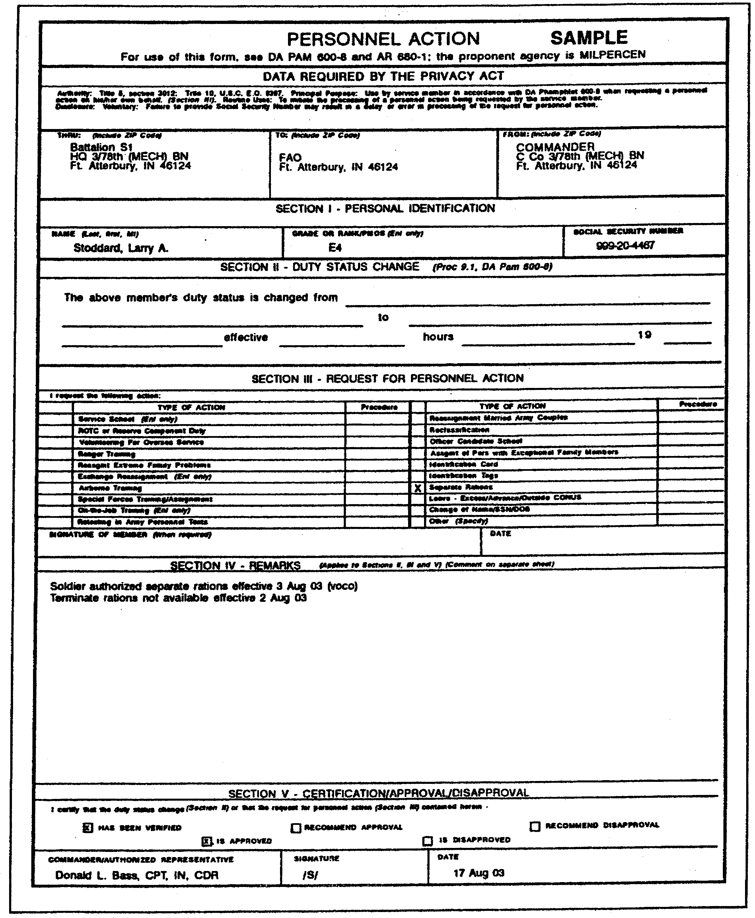

Figure 1-1. Completed DA Form 4187.

1-13 FI0175
b. Entitlement Upon Transfer. Entitlement to any of the following BAS rates automatically terminates upon your input and acceptance of a DEP PCS and/or an ARV PCS (depart or arrive permanent change of station), JUMPS data collection, version 3 (JDC III) codes) entry:

- Separate rations (SR)(item code: 40(B)).
- Rations not available (RNA)(item code: 40(H)).
- Emergency rations (EMR)(item code: 40(K)).

Entitlements to separate rations (SR) for PCS travel days are substantiated with DD Form 1351-2, Travel Voucher. During in-processing, however, you must give special attention to soldiers' records with respect to SR. You will need to obtain signed statements in an original and two copies from soldiers living with their dependents, and from single soldiers in pay grades E-7 through E-9, to substantiate payment of SR. The original signed statement is your JSD. Give copy 1 to the soldier and send copy 2 to his unit commander.

c. Reserve Component Soldiers. Reserve Component (RC) soldiers on active duty for training (ADT), annual training (AT), or full-time training duty (FTTD) who are entitled to per diem subsistence, are also entitled to SR. In these cases, you use a DD Form 1351-2 as the JSD rather than a DA Form 4187.

d. Termination of Entitlement. When a soldier ceases to be entitled to SR, his unit commander will send you another DA Form 4187 in an original and one copy. It will show the date and hour of termination of entitlement. This document is your JSD.

e. Prorated Subsistence. Entitlement to prorated subsistence allowance is always substantiated by a DD Form 1475, Basic Allowance for Subsistence-Certification, shown in figure 1-2.

f. BAS Adjustments Due to Travel. The travel branch ensures that a copy of every DD Form 1351-2 prepared for military personnel is furnished to the military pay branch. You, or your personnel, screen the DD Forms 1351-2 to determine if any BAS adjustments are necessary. One-time adjustments are entered in the Master Military Pay Account (MMPA).

g. Field Duty Adjustments. Enlisted soldiers are not entitled to BAS while TDY/TAD to field duty. Therefore, enlisted soldiers receiving BAS and officers are required to reimburse the government through the Finance and Accounting Office (FAO) for meals furnished. Meals available during field duty are considered as meals furnished for all soldiers.

FI0175 1-14
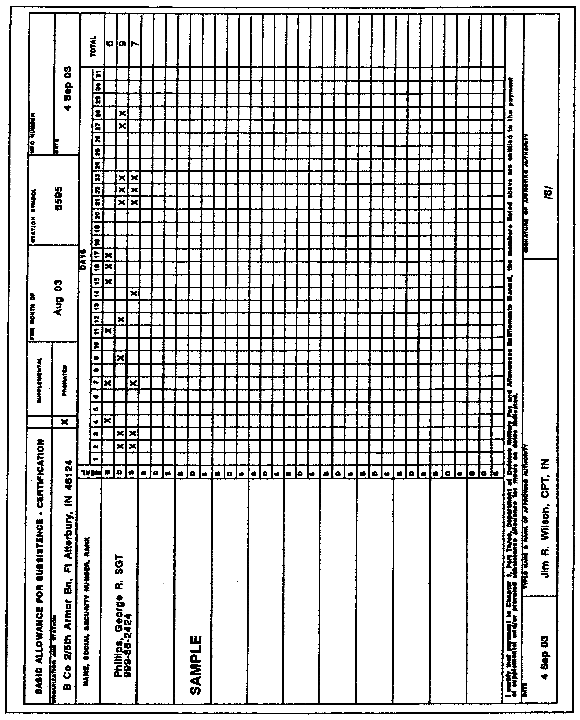

Figure 1-2. Completed DA Form 1475.

1-15 FI0175
(1) Enlisted. Field duty adjustments to BAS are made through input entries to the MMPA. For durations of 14 days or less a DA Form 4187 is prepared by the battalion S1 and forwarded to the FAO where a report duty field (SN03) entry is input to the MMPA. For durations of more than 14 days, the DA Form 4187 is also prepared upon departure and sent to the FAO where a start absence field (SN01) entry suspends the BAS. Upon a soldier's return, another DA Form 4187 is prepared and sent to the FAO where it signals a duty field (SN02) input to the MMPA restoring the soldier's BAS.

(2) Officers. When officers take part in field duty, reimbursement is made through payroll deductions by the FAO regardless of field duty duration. DA Form 4187 is prepared and submitted upon completion of the exercise. Collection is made for all meals available during the field duty period whether consumed or not. Amounts collected for the field meals are prescribed annually by HQDA.

PART B -BASIC ALLOWANCE FOR QUARTERS (BAQ)

Basic allowance for quarters is an allowance which is constantly subject to fraud and attempted fraud. As a finance officer, you must be able to determine entitlement and verify substantiating documents to ensure the soldiers are being properly paid by your office.

1. Soldiers Without Dependents.

Soldiers without dependents who are entitled to basic pay are entitled to BAQ at the rates found in DODPM table 3-2-9 and under the conditions prescribed in table 3-2-3 (appendix A). Except while on field duty, soldiers in pay grade E-7 and above may elect at any time not to occupy assigned government quarters and become entitled to BAQ.

Note: A seldom invoked exception to the above is when the Secretary of the Army determines the soldier's exercise of this option would adversely affect a training mission, military discipline, or readiness.

Turn to table 3-2-3 in the extracts (appendix A). Note the table is divided vertically into three columns: A, B, and C. The left side of the table is divided into "rules." To demonstrate how you read the table and determine entitlement, let's take a simple example under "rule 1."

FI0175 1-16
BAQ accrues (the soldier is entitled) when a soldier is assigned to a permanent station if government quarters or housing facilities are not assigned (see notes 3 and 11). BAQ does not accrue (the soldier is not entitled) if the soldier is assigned or occupies government quarters suitable and adequate for his grade (see notes 9 and 10).

Let's take another slightly more complicated example under rule 15.

For soldiers with less than four years service in pay grade E-4 who are in a travel status on a permanent change of station (PCS), including leave en route and proceed time, BAQ does not accrue on and after the day of departure from the old station.

In other words, the soldier's entitlement to BAQ terminates with his PCS. However, note 8 states:

"This rule is not applicable when the soldier is performing temporary duty (TDY) under PCS orders at a station which is ultimately the soldier's permanent duty station upon completion of his temporary duty; in such instances, see rule 1 of this table."

Thus, under the application cited in note 8, the soldier's entitlement would be dependent on whether the soldier is assigned or occupies government quarters at the new duty station.

a. Partial BAQ. Soldiers without dependents who are assigned to single-type quarters, or who are on field duty and not entitled to receive full BAQ, are entitled to partial BAQ at the rate provided in table 3-2-9 of the DODPM (appendix A). Paragraph 30214 of the DODPM (appendix A) also spells out the many conditions under which partial BAQ is authorized or not authorized.

b. Fraudulent Claims. Any soldier who submits a claim for BAQ which contains false statements is subject to court martial and criminal prosecution. In addition, fraudulent acceptance of benefits can make a civilian recipient subject to criminal prosecution. This would include a nonmember spouse or dependent. The law provides severe penalties of imprisonment and a fine. For military personnel penalties can include dishonorable separation, total forfeitures, and confinement.

c. Assignment and Termination of Government Quarters. The installation commander assigns and terminates quarters. The commander also determines what quarters are "adequate" and "suitable" for assignment. Government quarters or housing facilities under the control

1-17 FI0175
of the Army are considered as assigned, suitable, and adequate whenever occupied by a soldier at his permanent station without payment of rent.

This also applies to quarters furnished to a soldier without cost to the soldier in the following situations:

- Furnished by an organization or institution on behalf of the United States.

- Furnished by a foreign government for the soldier's official use.

- When jointly assigned to one or more single soldiers.

- When the soldier voluntarily vacates his assigned quarters without the permission of the installation commander.

Note: Soldiers in pay grade E-7 and above may elect not to occupy assigned quarters unless specifically denied permission by the Secretary of Defense.

d. Computation of BAQ. You compute BAQ in the same way as basic military pay. BAQ continues to accrue through the day before the date the soldier is assigned government quarters or begins to occupy unassigned government quarters on a nonrental basis at his permanent station. BAQ begins to accrue (except as indicated in DODPM table 3-2-3 [appendix A]) on the day assignment to government quarters is terminated. BAQ also begins to accrue on the date unassigned quarters are, in fact, vacated.

Example: A soldier's assignment to government quarters is terminated 25 August and BAQ would normally accrue from that date. But the soldier actually vacates the unassigned quarters 20 August. BAQ accrues to the soldier from 20 August.

2. Soldiers With Dependents.

Soldiers with dependents who are entitled to basic pay are also entitled to BAQ at the rates prescribed (see DODPM table 3-2-9 in the appendix), under the following conditions:

- Adequate government quarters are not furnished for the soldier and his dependents without rent.

- Adequate government quarters are not furnished for the soldier's dependents, or his dependents are prevented by competent authority from occupying such quarters even though the quarters are assigned for the soldier's occupancy.

FI0175 1-18
Dependents are not en route, or do not accompany the soldier to the permanent duty station, or to the vicinity thereof, so as to preclude assignment of family quarters.

Under such circumstances the mere availability of quarters which could have been assigned does not defeat the right of the soldier to BAQ for dependents.

a. Entitlement to Dependent Status. With respect to a soldier, a dependent is defined as follows:

(1) Spouse.

(2) Unmarried child including any of the following categories of children if such child is dependent upon the soldier:

- A stepchild.

- An adopted child.

- An illegitimate child whose alleged soldier-father has been judicially decreed to be the father of the child or legally ordered to contribute to the child's support, or whose parentage has been admitted in writing by the soldier, and the child is:

  - under 21 years of age.

  - incapable of self-support due to mental or physical incapacity, and relies on the soldier for over one-half of the dependent's support.

(3) Parent who relies on the soldier for one-half of his or her support. This category includes stepparents or parents by adoption, or any person who has stood "in loco parentis" (acting "in place of") the actual parent to the soldier at any time for a period of at least five years before the soldier reached the age of 21. However, the dependency of such a parent is determined on the basis of an affidavit submitted by the parent and any other evidence required under regulation prescribed by the Secretary of the Army. Also, the parent is not considered a dependent of the soldier claiming the dependence unless:

- the soldier has provided over one-half the support for the period prescribed by the Secretary of the Army, or

- circumstances change after the soldier enters on active duty, and, in fact, the parent relies on the soldier for over one-half his or her support.

1-19 FI0175
Of course, the relationship between a stepparent and a stepchild is terminated by the stepparent's divorce from the parent by blood.

Normally the Finance and Accounting Officer (FAO) makes the determination of dependency for entitlement to BAQ although, in some cases, the facts are forwarded to DFAS-IN for determination as shown in DODPM table 3-2-1 (appendix A).

Example: If a claimed dependent is the soldier's spouse (column A, rule 2), and the marriage is lawful (column B), then the determination is made by the FAO (column H).

If the dependent claimed is an unmarried child, under 21, adopted and dependent on an active duty soldier, and the adoption papers are available, you will make the determination (rule 4 with notes 4 and 8). If the adoption papers are not available, the determination is made by DFAS only if you cannot make the determination under chapter 21, section II, AR 37-104-3. If the adoption decree is interlocutory (not final), the case must be submitted to DFAS-IN.

b. Assignment to Government Quarters.

(1) Adequacy. As pointed out earlier, the issue of adequacy is determined by the installation commander.

(2) Nonfamily-type Quarters. A soldier who is neither assigned nor occupies government quarters is entitled to BAQ for dependents, even though the dependents occupy government quarters not designated as family-type quarters.

Example: A soldier's spouse occupies a single room in the quarters of a commissioned officer incident to employment as a domestic servant.

(3) Quarters Furnished on Behalf of the US. A soldier is not entitled to BAQ for dependents if the soldier and his family are furnished adequate family quarters on behalf of the United States without rent.

Example: Family quarters furnished a soldier and his family in an official capacity by a foreign government.

Example: Family-type quarters furnished by a college, university, or research facility as part of a fellowship, grant, or scholarship.

(4) Quarters Occupied by Soldier's Family Incident to Field Duty. A soldier whose dependents occupy public quarters while the soldier

1-20 FI0175
is on field duty is entitled to BAQ for a period not to exceed seven days (see rule 2, table 3-2-5, DODPM [appendix A]).

(5) Rental Quarters. A soldier and his dependents who occupy the following facilities on a rental basis are entitled to BAQ:

- Any-housing facility, including trailers, under the jurisdiction of the government, other than public quarters constructed or designated for occupancy without charge. The soldier may sublease such quarters with or without charge and neither the sublessor or sublessee will lose his BAQ entitlement.

- The hotel on the grounds of the United States Military Academy.

- Quarters furnished a soldier in connection with service in a capacity other than that of the soldier's primary duty assignment.

Example: Serving under Panama Canal deployment.

(6) Quarters Designated as Inadequate. A soldier with dependents may be assigned quarters on a rental basis which are designated inadequate without loss of BAQ. This does not apply to bachelor officer quarters (BOQ), visiting officer quarters, guest houses, and similar facilities, or to assigned quarters undergoing normal repairs. Be sure you increase rental charges if BAQ rates increase.

(a) Rental Charge. The rental charge is the fair-rental value for such quarters, except the rental charge may never exceed 75 percent of the occupant's BAQ at the with-dependents rate.

(b) Computation of BAQ/Rent. BAQ and rental charges are computed on a 30-day-month basis. You neither pay BAQ nor charge rent for the 31st of a month. You prorate both at 1/30th of the monthly rate for each day inadequate quarters are assigned. You pay three days BAQ and charge three days rent when inadequate quarters are assigned February 28th. You do not charge rent for the day the assignment is terminated. However, BAQ accrues for the day of termination if government quarters are not occupied on that day.

(c) Married Soldiers. Married soldiers who jointly occupy inadequate family quarters on a rental basis are entitled to BAQ according to their dependent status as provided for in table 3-2-4 of the DODPM (appendix A).

1-21 FI0175
Example: A married military couple where each has a child by a previous marriage, but where they have no children from their present union. If either soldier is, or both of them are assigned single-type quarters, both are entitled to BAQ at the with-dependent rate (DODPM table 3-2-4, rules 18 through 20).

Rental charges are 75 percent of the with-dependents rate BAQ payable to the person under whose eligibility the quarters are assigned. Collection is 50 percent of the charge from each soldier.

3. BAQ Entitlement During Travel.

Entitlement to BAQ may continue or be deemed not to exist under certain conditions of leave or travel status. DODPM table 3-2-5 (appendix A) is your source of information concerning such situations. Trace the following example through the table under rule 4.

Example: A soldier on excess leave loses his entitlement to BAQ if he is an officer or an enlisted soldier in pay grade E-4 or higher with four or more years of service.

4. Start/Stop BAQ.

The dates you start and stop entitlement to BAQ vary under different conditions. You will find guidance for establishing the dates in tables 3-2-6 through 3-2-8 in the DODPM (appendix A).

Example: Under rule 2, table 3-2-6 (Start BAQ), if a soldier with dependents is appointed to commissioned or warrant officer status, you begin the BAQ on the date active duty pay begins, providing the soldier is not assigned government family quarters on that date.

Example: Under rule 5, table 3-2-7, Stop BAQ-Status Changes, when the sole dependent child becomes of age, stop BAQ at 2400 hours of the day before that 21st birthday.

Example: Under rule 1, table 3-2-8, Stop BAQ-Other, if the soldier is furnished government quarters at the permanent station, adequate for the soldier and his family, you stop BAQ at 2400 hours before the day quarters are assigned (or occupancy begins if assignment is not definite, subject to note 1).

1-22 FI0175
5. Lawful Spouse and Legitimate Children.

A soldier's lawful spouse and legitimate, unmarried, minor children are generally considered proper dependents. Exceptions to this general rule are found in paragraphs 30224 and 30236 of the DODPM (appendix). A determination of relationship is required, but usually a determination of dependency is not. In all instances of a soldier having a spouse serving on active duty in the Army or another branch of the service, full details must be given and include the following:

- Full name.
- Social security number.
- Duty station.
- Branch of service.

When two service members with no other dependents are married to each other, they may elect which member will receive BAQ on behalf of children born of their marriage or adopted. If, for some reason, there is disagreement, the entitlement is given to the Senior service member. Entitlement can always be transferred to the other service member when merited.

Example: Promotion to a more senior rank, of either the husband or the wife.

When a stepchild is involved, either the natural parent or the stepparent may claim the child for BAQ, but the priority for entitlement rests with the natural parent. To claim entitlement on behalf of the stepchild, the stepparent must meet the criteria in DODPM paragraph 30239 (appendix A).

When one of two married soldiers is already receiving BAQ at the with-dependents rate on behalf of:

- an adopted child,
- a child from a previous marriage,
- an illegitimate child,

then any child born of their marriage is considered to be in the same class of dependents for which the spouse is receiving BAQ. In that event, the other marriage partner may not claim the child (ren) for BAQ. However, if the entitled soldier elects to stop receiving BAQ at the with-dependents rate, then the partner may claim the child of their marriage or adopted by them, for BAQ purposes. When spouses do not reside together in a common household due to military orders, determine entitlement on an individual basis. See table 3-2-4 of the DODPM in appendix A.

When one of two married soldiers is receiving BAQ at the with-dependents rate on behalf of a dependent parent, the other partner would be entitled

1-23 FI0175
to BAQ at the with-dependents rate for their child (ren). The entitlement would end if the family is occupying or assigned government-furnished quarters or if another soldier is entitled to BAQ in behalf of the children.

Note: This subcourse visualizes married soldiers for simplicity but the rules apply to marriages between members of any of the branches of the services.

6. Illegitimate Children.

Included in the definition of a dependent is an unmarried illegitimate child whose alleged soldier-father meets the following circumstances: soldier has been judicially decreed to be the father of the child, or judicially ordered to contribute to the child's support; or soldier has admitted, in writing, to being the parent.

Such a dependent must be under the age of 21 or be incapable of self support and dependent on the soldier for support due to mental or physical incapacity. A soldier can claim BAQ on behalf of an illegitimate child within the following guidelines:

- The claimant must furnish proof of parentage.

- If the child is in the custody of another person and the claimant is in single-type government housing, the claimant must show he or she provides monthly support at least equal to the applicable BAQ with-dependents rate.

- If the child is in the custody of either the soldier or another person and the soldier is not assigned government quarters, the soldier-parent can claim the child as a dependent if proof is shown that the monthly support provided is greater than:

- one-half the child's support, or:
- the difference between the applicable BAQ with and without dependents rates.

In any case where one-half the support exceeds the applicable BAQ at the with-dependents rate, support in at least the with-dependents rate is considered adequate for entitlement.

When both parents are in the service, the parent with physical custody of the child is the only one entitled to BAQ on behalf of the child. If neither parent has physical custody of the child, then the parent contributing the most support to the child is entitled. In either case, the soldier-parent must meet the guidelines outlined above. If the parents subsequently wed, the child is considered a legitimate child and a regular dependent.

1-24 FI0175
BAQ does not accrue to either the natural father or mother in the event the child is adopted by another person. The soldier may claim the illegitimate child of his spouse as a dependent, although he is not the father of the child. The child qualifies as a dependent, in the same manner as any other stepchild, when the soldier accepts full responsibility for that child by marriage to the child's mother.

7. Dependent Parents.

Dependency of a parent, or parents, is determined on the basis of an affidavit submitted by the parent, and any other evidence as required by regulations prescribed by the Secretary of the Army. Upon receipt of the application, the authority designated in table 3-2-1 (appendix A) sends a form to the parents for completion. A custodian or legal guardian can complete the form for a mentally incompetent parent. Naturally, if the case is being determined by DFAS, there will be a time delay before you are aware of the final determination. If a parent dies before completing the affidavit, payment of BAQ is precluded.

a. Dependency Requirement. Just because a soldier's parent or parents are living with him does not entitle that soldier to BAQ for his parents. The additional factor of dependency must be met. The parents must be dependent upon the soldier for over one-half of their support. This means:

- the parents' income, not counting the soldier's contribution, must be less than one-half of their monthly living expenses.

- the soldier's support must be more than one-half the parents' monthly living expenses.

b. Dependent Status Changes. A soldier can be paid BAQ for any active duty period during which dependency of the parent is shown to exist, whether such dependency arose before or after the soldier entered the Army. If dependency arises due to changed circumstances, and the facts show the soldier has started to contribute over one-half of the parents' support, then you can pay BAQ from the date the contributions began. No waiting period is required.

c. Stepparents. A stepparent-stepchild relationship ends with divorce from the blood parent, but not upon the death of the blood parent. Thus, BAQ entitlement may be established after death of the blood parent.

Example: A soldier's mother and stepfather are able to support themselves on social security and require no aid from the soldier. The mother becomes ill and dies after a three-month illness. During

1-25 FI0175
that three-month period the soldier paid more than one-half the mother's expenses. The soldier is entitled to BAQ in behalf of his mother for those three months.

d. Determining Factors. Contributions made to parents by charitable organizations are not considered income. Also the residence in a charitable institution, public or private, is not a bar to entitlement if other conditions of entitlement are met. Social security payments, pensions, or unemployment compensation are considered income. Unliquidated capital is not considered income, nor are parents required to liquidate such assets to establish dependency. However, proceeds from the liquidation of capital assets are considered income. Amounts placed in reserve for depreciation of property held for income normally are considered available for current living expenses; therefore, they are considered income. If you are determining dependency of parents with uninvested capital, compute the income return on the basis of 5 1/4 percent per year.

8. BAQ In a Nonpay Status.

BAQ for soldiers with less than four years service in pay grades E-1 through E-4 with dependents is authorized under the same conditions as specified for other enlisted soldiers. The exception is when the soldier is in a nonpay status. Entitlements are then paid as follows:

a. Unauthorized Absence or In Hands of Civil Authorities. You can pay BAQ, at the rate being credited a soldier at the time absence commenced, to a dependent on whose behalf BAQ was claimed prior to commencement of the absence. Such payment will not exceed two months from the first day of absence and will be under the following conditions.

- The soldier has been in an unauthorized absence status for more than 29 consecutive days.

- The dependent applies for payment of BAQ and the application is received by the appropriate authority within three months after the date absence commenced. If the Army fails to provide timely notice to dependents of their right to apply for BAQ, a waiver of the three-month stipulation may be granted on a case-by-case basis through DFAS-IN. If such a waiver is granted, payment may only be made on those applications received within two months after the dependents were properly notified of their right to submit an application.

FI0175 1-26
- No positive information has been received that the dependent is residing, or has joined the soldier at the place of absence. The soldier had not been assigned government family-type quarters (adequate or inadequate). If such quarters had been assigned, no BAQ could be paid.

Payment is made only to dependents living in the soldier's home, but not to the soldier on behalf of the dependent(s). This includes dependents who, for reasons of separation pursuant to competent orders, were not actually living with the soldier at the time the absence began.

b. Pretrial Confinement in a Foreign Country. Payment of BAQ is authorized as follows:

- For enlisted soldiers with less than four years service in pay grades E-1 through E-4, but not for more than two months under the conditions stated above (paragraph 8a). For any subsequent months there must be a showing of hardship on the dependent. Approval by DFAS-IN is on a case-by-case basis.

- For enlisted soldiers with more than four years service in pay grades E-4 and above. DFAS-IN is the sole approval authority for the initial and all subsequent payments. No payments are made without DFAS-IN approval on a case-by-case basis. Payments are also subject to all conditions stated in paragraph 8a above.

c. Excess Leave. You continue to pay BAQ to a soldier with less than four years service in pay grade E-4 or below, with dependents, for a period not to exceed two months during which an excess-leave status exists. The exception is when it is anticipated that the soldier will not return to active duty, for example, when he is on appellate leave. The two-month period is computed from the first day of excess leave. See DODPM table 3-2-5 (appendix A) for other examples of entitlement limitations in a nonpay status.

9. Substantiation/Documentation.

Under procedures utilized by the Joint Uniform Military Pay System-Active Component/Joint Services Software (JUMPS-AC/JSS), certain JUMPS substantiating documents (JSDs) are required to substantiate claims for allowances, including BAQ.

a. Government Quarters at Station. If government quarters are maintained at the soldier's station, a signed statement by the installation commander, that government quarters were not

1-27 FI0175
available, substantiates entitlement to BAQ. In pay grades E-7 or higher, the soldier's own choice not to occupy assigned quarters entitles that soldier to BAQ-own election (BAQOE), and his signed statement to that effect also serves to substantiate the BAQ credit.

b. Government Quarters Not at Station. A statement signed by the installation commander to the effect that no government quarters are maintained at the installation substantiates BAQ credit in the master military pay account (MMPA). The commander's statement must also include a statement that the soldier is not assigned, and does not occupy, government quarters.

c. Submission of Statements. Statements to substantiate input to the MMPA are sent to you on a daily basis in transmittal letters (TLs) from the commander or unit personnel officer. No further statements relative to the availability or occupancy of government quarters are necessary while the soldier is at that station unless a change in entitlement occurs.

d. Inadequate Quarters. The finance and accounting officer takes the following actions when a soldier and spouse (also a soldier) occupy inadequate quarters on a rental basis and both soldiers are being credited with BAQ according to their dependent status as determined by DODPM table 3-2-4 in appendix A.

(1) An entry to the MMPA is input to collect the appropriate percentage of the fair-rental amount from each soldier. The rental charge is the fair-rental value of the quarters except it can never exceed 75 percent of the soldiers' BAQ at the with-dependents rate. Fifty percent of the rental charge is collected from each soldier.

(2) The letter or memorandum assigning the soldier and spouse to inadequate quarters is used as the JUMPS substantiating document (JSD).

(3) If the fair-rental amount changes, an appropriate change input is made to the MMPA.

e. Other Documentation.

(1) DA Form 5960, Authorization to Start, Stop or Change BAQ and/or VHA (figure 1-3). Soldiers applying for BAQ fill out DA Form 5960 in the original and one copy. They complete the top portion of the form as prescribed below.

(a) NAME. The soldier fills in his or her name.

1-28 FI0175
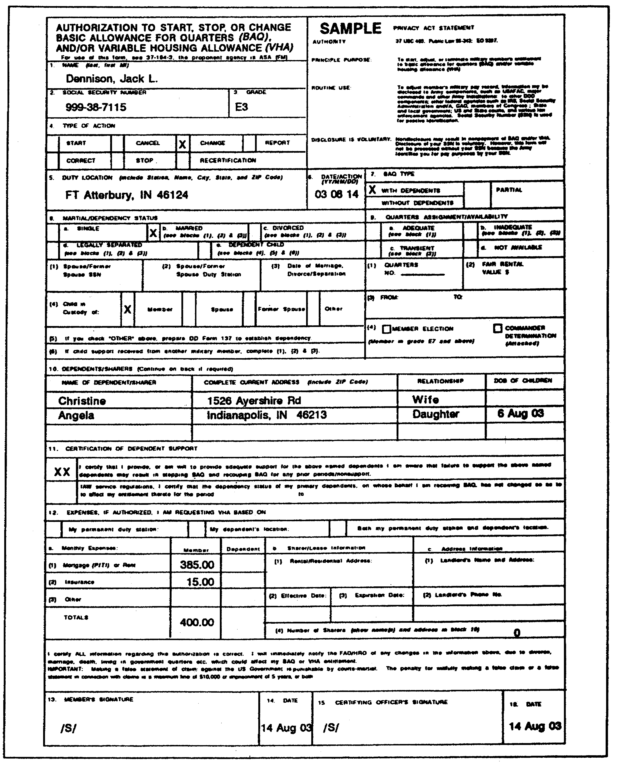

Figure 1-3. Completed DA Form 5960.

1-29 FI0175
(b) SOCIAL SEC. NO. The soldier enters his social security number.

(c) GRADE. The soldier fills in the appropriate pay grade, such as E-3, O-2, WO-4, etc.

(d) TYPE OF ACTION. Check "START" (or the appropriate box).

(e) DUTY LOCATION. The soldier enters the complete unit of assignment including ZIP code.

(f) DATE/ACTION. The soldier enters the current date in the YYMMDD format.

(g) BAQ TYPE. The soldier checks the appropriate box.

(h) MARITAL STATUS. The soldier checks the appropriate box and is referred to subsequent entries depending on which box was checked. If the soldier checks "Other" in the "Child in Custody of" section, he is directed to prepare a DD Form 137 to establish dependency.

(i) QUARTERS ASSIGNMENT/AVAILABILITY. The soldier checks the appropriate box and is referred to subsequent entries. The Member Election is available to grades E-7 and above, otherwise, the Commander's Determination must be attached to the form.

(j) DEPENDENTS/SHARERS. The soldier enters all dependents if claiming BAQ, or all roommates it claiming VHA.

(k) CERTIFICATION OF DEPENDENT SUPPORT. The soldier initials both boxes and fills in the dates in the lower box.

(l) EXPENSES. IF AUTHORIZED, I AM REQUESTING VHA BASED ON. If the soldier is claiming entitlement to the variable housing allowance, he completes item 12 by checking the appropriate box and entering the requested information.

(m) The soldier and certifying officer sign and date the DA Form 5960 at the bottom of the form.

(2) DD Form 137, Application for Basic Allowance for Quarters for Members with Dependents (figure 1-4). Use this form only when the claim for BAQ entitlement must be submitted to DFAS-IN. Assist soldiers taking application for BAQ in filling out DD Form 137 in an original only.

FI0175 1-30
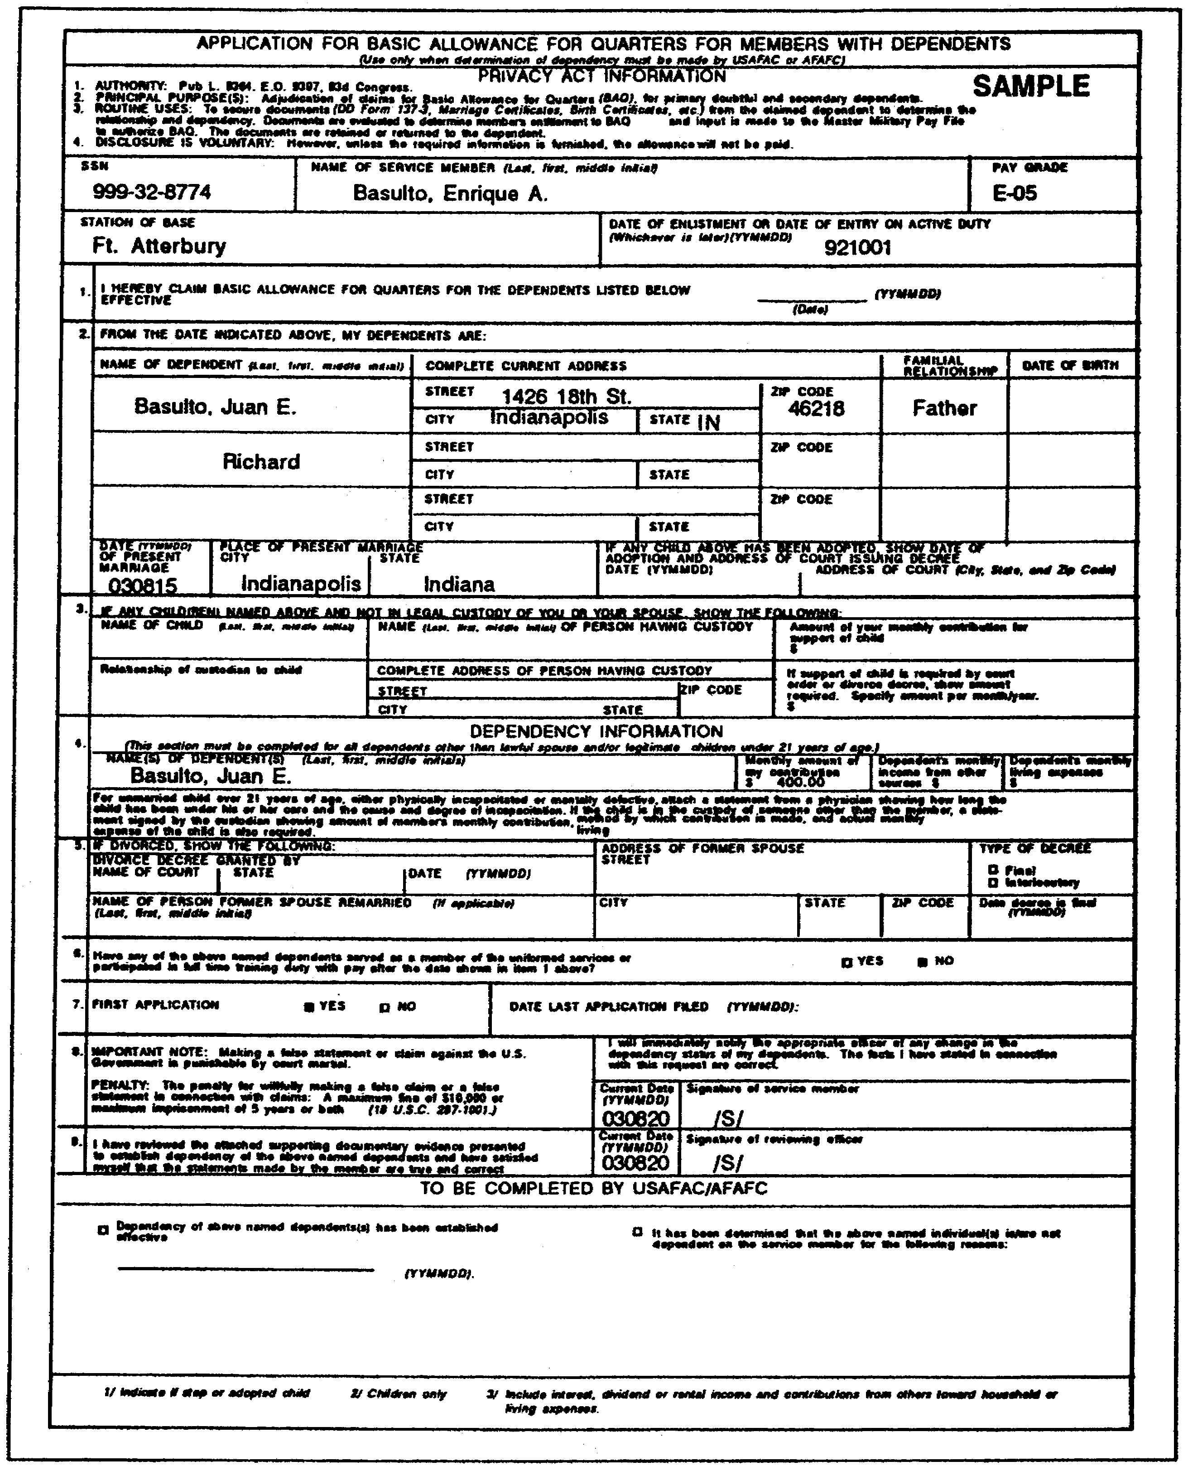

Figure 1-4. Completed DD Form 137.

1-31 FI0175
Make an original and one copy if the claim involves unmarried illegitimate children under 21 years of age for which the FAO must establish BAQ.

(a) Heading. The soldier must complete all items of the heading as applicable. He must record his name, pay grade, social security number, complete service mailing address and ZIP code, and basic active service date (BASD).

(b) Block 1. The date shown here is the effective date of claim for BAQ as follows:

- On applications for initial establishment of entitlement to credit for BAQ, the date is the date from which credit is claimed.

- On applications for re-establishment on termination of government quarters, the date indicated is the new date from which credit is claimed.

(c) Block 2. Here, the soldier enters the last name, first name, and middle initial of the dependent on whose behalf he is claiming the allowance. In figure 1-4, the soldier has claimed BAQ credit on behalf of her father.

- Complete Current Address, Including ZIP Code. The current address of the dependent is entered here. If, during the 12 months immediately preceding preparation of this form, the dependent lived elsewhere than at the current address, list each additional address and period of residence on the reverse of the form. Place the notation: "SEE REVERSE" in this block.

- Relationship. Show the exact relationship of the claimed dependent to the soldier.

- Date of Birth. Complete this item only if a child is claimed.

- Date and Place of Marriage. This entry is made only if the marriage is of questionable legality.

- Adopted Child Data. If the soldier is claiming BAQ on behalf of an adopted child, you must furnish a certified court adoption decree with the claim. If the documentary evidence is not available, show the date of adoption, the reason the court adoption

FI0175 1-32
decree is not available, and the name and address of the court issuing the adoption decree.

- Illegitimate Child Data. If the soldier claims BAQ on behalf of an illegitimate child, he must furnish the following:

  - A copy of the judiciary decree that the soldier is the mother or father of the child.
  - A copy of the judiciary order for the soldier to contribute to the child's support.
  - A written statement by the father or mother admitting parentage.

In any case involving foreign court decrees, parentage also must be admitted to in writing and under oath.

(d) Block 3. The soldier will furnish appropriate information about the child shown in block 2 who is not in the custody of the soldier or spouse. Enter the name and address of the person having custody of the child, relationship thereto, and the amount contributed monthly by the soldier for the child's support. If support of the child is required by a court order or divorce decree, show the amount required for support. Attach a statement signed by the child's custodian showing the amount of the soldier's contribution and the actual living expenses of the child.

(e) Block 4. The required information must be furnished on the dependent on whose behalf the allowance is claimed. Omit the dependent's income and expenses if unknown. Important note: a soldier will not be denied the right to file a dependency application in the absence of knowledge as to the income and expenses of the dependent claimed.

(f) Block 5. This item is self-explanatory.

(g) Block 6. Check either Yes or No.

(h) Block 7. Check the appropriate block. If the "NO" block is checked, show the date the last application was submitted, and whether it was filed while the soldier was a member of the Army, Navy, Air Force, or Marine Corps.

(i) Block 8. Have the soldier read the note in block 8, and then date and sign the certificate.

1-33 FI0175
(j) Block 9. This is the certification of the reviewing officer. The FAO examines the application and, if it is complete, he dates and signs the certificate and enters his disbursing station symbol number (DSSN).

Note: When dependency status remains unchanged, DA Form 5960, if approved, substantiates the credit of BAQ from the date claimed to the date of the next PCS recertification. Claims for BAQ involving DA Form 137 are controlled by DFAS-IN with regard to both initial entitlement and annual recertification.

f. BAQ Credit for In-transit Soldiers Without Dependents. Under provisions shown in DODPM table 3-2-3, soldiers without dependents in pay grades E-4 and above, with over four years service, may be entitled to BAQ at the without-dependents rate when in a travel status between permanent duty stations. This includes periods of TDY, leave, and proceed time en route.

If entitlement exists, the computer will automatically pay the entitlements based on the departure and arrival PCS entries.

No JSD is required to be sent to DFAS-IN for payment of BAQ during PCS or TDY. The original DD Form 1351-2 which is routinely sent to DFAS-IN for substantiation of travel payments can be used to verify payment of BAQ, if necessary. Soldiers are normally entitled to the variable housing allowance when they receive BAQ. The variable housing allowance (VHA) is covered in Part D of this lesson.

PART C -FAMILY SEPARATION ALLOWANCE (FSA)

Another military allowance often encountered by the military pay branch is the family separation allowance (FSA). You must be able to quickly and accurately determine entitlement, compute the amount due, and verify and certify documents supporting this entitlement.

1. Family Separation Allowance (FSA) Provisions.

FSA is payable only to soldiers with dependents. Two types of FSA are authorized: FSA Type I, and FSA Type II. Both types of FSA are payable in addition to any other allowance or per diem to which the soldier might be entitled. In addition, a soldier can qualify for both FSA Type I and FSA Type II for the same period. In such cases, concurrent payment of both types is authorized. However, a soldier cannot receive more than one payment of FSA Type II for the same period, even though he may qualify for

FI0175 1-34
FSA-R and FSA-S or FSA-T. (More on those subclassifications later.) The purpose of FSA and the conditions of entitlement to the allowance are the subjects of this part of the lesson.

For the purposes of administering FSA, dependents are classified as follows: Primary (spouse or children) or Secondary (parents).

Note: A person serving in the armed forces and entitled to basic pay is not considered a dependent for FSA purposes.

For the purposes of FSA, a household means the same thing as "home" or "family." The term applies to a collection of persons living under one roof and having one head or manager who controls and supervises the affairs of the family. In the case of FSA Type II entitlement, this applies only to secondary dependents.

The term "overseas" applies to a location outside the 48 contiguous United States, the District of Columbia, and Hawaii for the purposes of FSA Type I.

2. FSA Type I.

The purpose of this FSA is to reimburse a soldier for added housing expenses incurred through enforced separation from dependents. FSA Type I applies when two homes must be maintained: one for the dependents, and one for the soldier. You do not pay FSA Type I, under any conditions, to a soldier stationed in Hawaii or sent to any duty station under permissive orders, except when those conditions are incident to PCS reassignments. Nor do you pay FSA Type I to any member of the Armed Forces attached to the United States Truce Supervision Organization who is receiving the United Nations Mission Subsistence Allowance (mission per diem).

a. When Payable. You pay FSA I to each soldier with dependents who is on permanent duty outside the United States, or in Alaska and who meets all of the following conditions:

(1) Transportation of dependents to the permanent station or to a place near that station is not authorized at government expense.

(2) Dependents do not live at, or near, the permanent duty station.

(3) Adequate government quarters or housing facilities are not available for assignment to the soldier, and inadequate government quarters or housing facilities are not assigned.

b. Amount Payable. FSA Type I is payable in the amount equal to BAQ payable to a soldier without dependents in the same pay grade. For

1-35 FI0175
amounts of FSA Type I entitlement, turn to DODPM table 3-2-9 (BAQ rates) in appendix A.

c. Conditions. For some basic examples of specific entitlement to FSA Type I, look at DODPM table 3-3-1 in appendix A.

Example: A simple case of entitlement is found under rule 1 where a soldier's PCS overseas assignment is to an area where dependents are not permitted. (columns B, C, D, and E are not applicable.) The soldier's entitlement to FSA Type I exists for the entire unaccompanied tour of duty, subject to note 1 (which would not likely apply).

Example: Under rule 6, a soldier's overseas PCS assignment is to an area where concurrent travel is automatically authorized, or to an advance application area, and the soldier elects to serve the "with command sponsored dependents" option before departing the continental U.S. (CONUS)(column B). If concurrent travel is not authorized by the area commander (column C), but the soldier complies with all area regulations for entry of dependents (column E), then his entitlement to FSA Type I continues through the day before his dependents arrive at the overseas station. The entitlement is not to exceed 60 days from the date dependents' transportation is authorized unless the delay is caused by the government (column F).

3. FSA Type II.

FSA Type II provides compensation for added expenses incurred due to an enforced family separation under conditions outlined in paragraphs 3a(l), (2), and (3) below. It is payable to soldiers serving inside or outside the U.S. FSA Type II is not authorized in time of war or national emergency declared by Congress, or when a soldier performs duty at any station under permissive orders (with some exceptions in overseas assignments).

a. Requirements. You pay FSA Type II to all soldiers with dependents regardless of length of active service and pay grade. The soldier must meet all of the general criteria for FSA Type I discussed in paragraph 2 and one of the following conditions:

(1) FSA-R When transportation of the dependents is not authorized at government expense and the dependents do not live at, or near, the soldier's permanent duty station, the soldier is entitled to a separation allowance called FSA-R.

FI0175 1-36
(2) FSA-S. When a soldier is on duty aboard a ship, away from the ship's home port continuously for more than 30 days, he is eligible for FSA-S. Naturally, this is not common in the Army, but it can apply.

(3) FSA-T. When a soldier is on TDY or TAD away from the permanent station continuously for more than 30 days and his dependents do not live at, or near, the TDY station he is entitled to FSA-T. This category includes soldiers required to perform a period of TDY before reporting to their initial station of assignment.

(FSA Type II was payable at a rate of $75 per month at the time this subcourse was written.)

b. Conditions. This part of the subcourse will deal with conditions of entitlement common to both types of FSA. For some basic examples of specific entitlement to FSA Type II, look at DODPM tables 3-3-3 through 3-3-6 in appendix A.

Example: Table 3-3-3, rule 4: A FSA-entitled soldier is on authorized leave and his permanent station remains the same. His FSA-R continues through his leave. Under rule 12, the soldier is on TDY for more than 30 days en route to a new permanent station. He will not qualify for FSA-R at the new station. Then the soldier is entitled to FSA-T for authorized travel time to and from the TDY station and for duty at the station, subject to note 4.

Example: Table 3-3-4, rule 9: A soldier is assigned outside CONUS (OCONUS) and his dependent lives near the OCONUS station. The soldier qualifies for FSA-R for other dependents who are not authorized to travel to the OCONUS station. In that event, the soldier is entitled to FSA-R.

Example: Table 3-3-5, rule 2: A soldier departs Fort Atterbury, IN on 26 January 2003, goes on leave from 26 January through 4 February 2003, and departs St. Louis, MO on 4 February 2003, arrives in Seoul, Korea on 5 February 2003. The soldier's FSA would start on 4 February 2003.

Example: Table 3-3-6, rule 3: On 15 May 2003, SGT Jones returns from a 90-day TDY assignment with no delay en route or proceed time authorized. His FSA-II credit continues through '14 May 2003.

1-37 FI0175
4. Separation Requirements.

a. Dependents. Do not consider a soldier "a soldier with dependents" for FSA-II entitlement if:

- the sole dependent is placed in an institution for a known period of over one year, or for an indefinite period expected to last over one year.

- the sole dependent is a child in the legal custody of another person, or a legally separated spouse.

- the dependent parent does not live in the soldier's household.

b. Temporary Visits.

(1) FSA Type I and FSA-R. Credit continues to accrue while the soldier's dependents visit at or near the soldier's permanent station, but for no longer than three continuous months. The evidence must clearly show the social visit is temporary and not intended to last more than three months. If, for unforeseen reasons such as illness or emergency, the visit extends beyond three months, you stop credit for FSA at the end of three months.

If the visit is intended to exceed three months, you stop FSA credit the day before the dependents arrive and restore it the day they leave the soldier's permanent station. However, a soldier is entitled to FSA Type I and/or FSA-R even though one or more, but not all, dependents visit for longer than three months, if the soldier is entitled on behalf of any of the dependents who do not visit.

Example: CSM Ward's permanent station is Stuttgart. He was not authorized to bring his dependents to Stuttgart at government expense. His two daughters come to Germany for a five-month visit and stay with their father at his government quarters. CSM Ward's wife and three sons remain in the United States. CSM Ward's FSA-R on behalf of the wife and three sons remains in effect. CSM Ward's monetary entitlement remains the same.

(2) FSA-T. Credit continues to accrue to a soldier whose dependents visit at, or near, a temporary duty (TDY) station continuously for 30 days or less. The facts must show the dependents are merely visiting. If the visit exceeds 30 days, the soldier is not entitled to FSA-T for any part of the period, unless the visit is extended because of illness or some other emergency. Under such circumstances, payment of the allowance is limited to 30 days. You resume entitlement td FSA-T

FI0175 1-38
the day the dependents depart the TDY station if the soldier's TDY continues for 30 days past the departure date. Entitlement to FSA-T exists if one or more, but not all, of the dependents visit for longer than 30 days, if the soldier is entitled on behalf of the dependents who are not visiting the soldier.

(3) FSA-S. Credit continues to accrue to the soldier whose dependents are visiting at, or near, the duty station continuously for 30 days or less. It must be obvious the dependents are only visiting. If the visit exceeds 30 days, entitlement to FSA-S ends on the day preceding the date of their arrival, unless the visit is extended because of illness or other emergency. Under such circumstances, payment of FSA-S is limited to 30 days. Entitlement to FSA-S exists if one or more, but not all dependents visit for longer than 30 days, if the soldier is entitled to FSA-S on behalf of the dependents who are not visiting the soldier.

c. Dependents Reside Near Duty Station. FSA does not accrue to a soldier if all the dependents live near, or at, the duty station. If some, but not all of the dependents live near, or at, the station, FSA may accrue on behalf of the dependents who do not live near.

Example: A soldier has a wife and son living with him within commuting distance of the installation, but a daughter is attending school in a town over 300 miles distant.

Commanders consider dependents as "living near or at" the station if the soldier commutes daily, regardless of the distance involved. Otherwise, 50 miles is generally considered a "reasonable" commuting distance. But, that rule is not inflexible. When the distance is less than 50 miles but the time required to reach the post would exceed 1 1/2 hours, the dependents would not be considered as living at, or near, the duty station.

Example: A soldier's home is located 45 miles distant across the bay, but the time required to reach the post via the only circuitous route around the water, requires three hours traveling time.

If dependents are authorized concurrent travel with the soldier, and they are subsequently authorized to live at a location more than 50 miles distant from the duty station for personal reasons rather than military restrictions on dependent's travel, then FSA would not accrue. In questionable cases, commanders submit requests for determination through channels to the appropriate authority at DFAS-IN.

1-39 FI0175
5. General Conditions of Entitlement.

a. CONUS PCS. This paragraph concerns FSA entitlement incident to regular PCS reassignments (CONUS) and permissive PCS reassignments (CONUS).

(1) Regular PCS. Entitlement to FSA upon regular PCS is authorized only when the movement of a soldier's dependents to the new permanent station is not authorized at government expense.

(2) Permissive PCS. A soldier who is otherwise authorized movement of dependents to the permanent duty station at government expense, is not so authorized when he is voluntarily reassigned PCS under permissive orders. Separation under these circumstances is not an enforced. separation due to Army requirements. The soldier therefore, is not entitled to FSA.

b. Overseas PCS. A soldier selected for PCS overseas to an area where dependents are permitted must elect to serve either an unaccompanied or accompanied tour. This also applies to reassignment between OCONUS bases.

(1) If otherwise eligible, a soldier assigned PCS and authorized an accompanied tour overseas who elects an unaccompanied tour is not entitled to FSA according to DODPM tables 3-3-4 (appendix A).

(2) A soldier who is voluntarily reassigned PCS (OCONUS) under permissive orders from a station (OCONUS) where the soldier is already entitled to FSA remains entitled to FSA so long as he continues to meet the other requirements for eligibility.

c. Unusual Family or Operational Circumstances. The Army defines unusual family or operational circumstances as those in which the Secretary of Defense determines it is in the Army's best interests to permit payment of FSA-II to a soldier who, through no fault of his own, must relocate unaccompanied under the following circumstances:

- When the soldier is ordered to a new overseas duty station where certified medical reasons involving family members, or where terrorist activity would make it inappropriate for dependents to accompany the soldier.

- When ships in overhaul make temporary home-port changes.

FI0175 1-40
- When married military couples with children are involuntarily separated by military orders.

Under these circumstances, waivers are effective on the date they are granted.

d. Government Caused Delays. In the tables and text you have seen references to "government caused delays." These include the following:

- A lack of transportation facilities.

- Disapproval of dependents' travel by CONUS commanders.

- Disapproval of dependents' travel for reasons of health (pregnancy of wife, etc).

- Insufficient service retainability or time remaining in the overseas tour.

Example: SGT A. M. Owens' advance application for concurrent travel of dependents was disapproved on 1 July 2003 by the CONUS commander. The commander based his denial on the fact that sufficient government-owned transportation facilities were not available. The commander's denial contained the statement that the anticipated delay to move the dependents would be for more than 60 days.

SGT Owens left his old station on 6 July 2003, and arrived at the new overseas station 7 July, where he found government quarters were unavailable. His dependents joined him on 26 September, after traveling on orders dated 10 September 2003.

SGT Owens is entitled to FSA Type I for the period 7 July through 25 September 2003, and FSA Type II for the period 6 July through 25 September 2003.

e. Tour Elections. Rules 3 and 8 in table 3-3-1 and rules 12 and 13 in table 3-3-4 in appendix A illustrate options open to soldiers and the result in FSA entitlement. Let's look at an example under rule 8, table 3-3-1.

Example: The soldier's overseas PCS assignment is to an area where concurrent travel is automatically authorized, or to an advance application area, and the soldier elects to serve in the accompanied tour before departing CONUS. Concurrent travel is not performed. If the soldier changes his election to an unaccompanied tour before the dependents leave the

1-41 FI0175
United States, then the soldier's entitlement to FSA Type I continues through the entire unaccompanied tour, if otherwise eligible. If the soldier is not drawing FSA Type I, entitlement accrues on and after the date his reelection is approved.

f. Dependents Evacuated. A soldier is entitled to proper payment of FSA Type II when his dependents are evacuated from a danger zone and they temporarily occupy government quarters at a safe haven. The FSA entitlement would be as outlined in paragraph 30222g of the DODPM in appendix A.

Example: A soldier has a dependent leave his overseas duty station at government expense because evacuation (other than medical) was ordered by the Secretary of Defense as being in the national interest, or for other emergency reasons, not personal, or not caused by the dependent's misconduct. The soldier's FSA credit commences on the date of the dependent's departure from his duty station. (table 3-3-2, rule 14)

g. Dependents' Travel Prohibited Under Immigration Laws. Entitlement to FSA-R does not exist when a dependent otherwise authorized to travel at government expense is not eligible under immigration laws to enter the United States before a soldier reports to a new permanent station. However, this condition does not affect entitlement to FSA-T or FSA-S.

6. Exercises Lasting More Than 30 Days.

Otherwise qualified soldiers of a unit ordered on an exercise for more than 30 days are entitled to FSA-T.

7. FSA During a Missing Status.

a. Special FSA Entitlement. A soldier with dependents who was declared missing during the Vietnam conflict is entitled to a family separation allowance of $60 per month for the period he is carried in the missing status. This provision applies to soldiers who do not qualify for FSA-II under the normal provisions prior to entering the missing status. Entitlement begins on the date the soldier is reported missing and continues for the period he is carried in a missing status.

b. FSA-T During a Missing Status. FSA-T continues to accrue to a qualified soldier while he is carried in a missing status. This remains true unless there is a change in the status of the dependents which would terminate entitlement, such as is reflected in DODPM table 3-3-6 in appendix A. Also a soldier can qualify for FSA-T while in a missing

FI0175 1-42
status, if a continuous period of more than 30 days is completed after he was declared missing.

Example: A soldier leaves his permanent station on a TDY mission 9 August 2003. His aircraft is shot down by hostile fire 2 September 2003, while flying over enemy-held territory. He remains in missing status until 4 November and returns to his permanent station on 10 November 2003. The soldier qualified for FSA-T on 8 September. If he is otherwise qualified, his FSA-T entitlement exists for the period of 9 August to 9 November.

8. TDY in Excess of 30 Days.

Do not make credit for FSA-T until the soldier has been on TDY continuously for more than 30 days. You compute this period as follows:

a. Count the actual number of days in the month, including the day the soldier leaves his permanent duty station and the day of return to the permanent duty station. Include the 31st day of the month in the computation even though payment is made on a 30-day-month basis.

b. Include days of authorized travel time to and from the TDY station. When there is no delay en route chargeable as leave, count the day of departure from, and day of return to, the permanent station. When delay en route chargeable as leave is authorized, count the "constructive" day of departure and the "constructive" day of return. Compute "constructive" days as follows:

- The constructive day of departure from the permanent station is the actual date of departure plus the number of days of leave authorized and used.

- The constructive day of return to the permanent station is the actual date of return minus the number of days leave authorized and used.

Example: SGT I. B. Smith is permanently stationed at Fort Atterbury, Indiana. SGT Smith is ordered to Fort Carson, Colorado for training of approximately 30 days. He is authorized to travel by privately owned conveyance as being more advantageous to the government, and five days leave en route. SGT Smith leaves Fort Atterbury 25 May 2003 and uses five days leave en route to Fort Carson. SGT Smith completes his training 27 June, and returns to duty in Indiana 30 June 2003.

1-43 FI0175
The constructive day of departure is 30 May. The period of absence is 32 days (30 May-30 June). If SGT Smith is qualified for FSA Type II, entitlement exists to FSA-T for 30 days.

Example: The situation is the same as above except the soldier uses five days of leave after completion of training. He departs from Fort Atterbury 30 May, completes his training 27 June, and departs from Fort Carson 28 June, and returns to duty at Fort Atterbury 5 July. The constructive day of return is 30 June. The period of absence is 32 days, computed as in the above example. If otherwise qualified, the soldier is entitled to FSA-T for 30 days.

c. When TDY is authorized in conjunction with PCS, include days of authorized travel time to the TDY station and from the TDY station to the new duty station. When there is no delay en route and/or proceed time involved, count the day of departure from the old duty station and the day of arrival at the new duty station.

When delay en route and proceed time are authorized and used, the day of departure from the old station and the day of arrival at the new station will be constructed in the manner indicated in the bullets in paragraph 8b above. Include proceed time authorized and used with the delay in your computation. Combine consecutive assignments to TDY with PCS in determining the 30-day period.

d. Under specific circumstances, when travel in connection with TDY is performed by privately owned conveyance for the convenience of the traveler, payment based on actual travel expenses may be more economical to the government than payment based on constructive travel time over a usually traveled route. In such a case, the Joint Federal Travel Regulations (JFTR) authorize travel payment based on the actual mode of transportation. In computing the more than 30 days needed for entitlement to FSA-T under these circumstances, ensure the computation is based on the mode of transportation which governed payment of the particular soldier's travel allowance. Computation for FSA-T entitlement under this rule is not necessarily based on constructive travel time.

e. If a soldier's TDY status is interrupted, do not combine days before the interruption with those after the interruption to compute a continuous period of more than 30 days. The following conditions do not interrupt the 30-day period unless the soldier is relieved from attachment to the TDY station:

FI0175 1-44
- Periods of leave.
- Hospitalization.
- Military confinement in a pay status.
- Short visits to the permanent station.

However, a soldier who returns to the permanent station to assume a duty status (such as participation in official flights) does interrupt a period of temporary duty. If leave en route is authorized after detachment from the TDY station, add constructive travel time from the TDY station to the permanent station, to the period of TDY in determining the 30-day period.

9. Soldiers Married to Soldiers.

In cases of soldiers married to soldiers where they have a child which either parent can claim for BAQ, one parent may claim the child for BAQ entitlement and the other parent, if otherwise entitled, may claim the child for FSA. FSA entitlement can alternate between the parents based on the same dependent, but do not pay FSA simultaneously to both parents on behalf of the same dependent.

10. Substantiation of FSA.

a. FSA Type I. The substantiating document for family separation allowance Type I is the DD Form 1561 shown in figures 1-5 and 1-6. Local SOPs spell out what additional documentation is required for nonavailability of single quarters.

b. FSA Type II. Family separation allowance (during PCS) is paid on a DD Form 1561. FSA (during TDY) is also substantiated by the DD Form 1561. You can verify the document, if necessary, with the soldier's DD Form 1351-2 which is routinely sent to DFAS-IN for substantiation of the travel payment.

PART D - VARIABLE HOUSING ALLOWANCE

1. Purpose.

The variable housing allowance (VHA) is authorized to assist soldiers entitled to a basic allowance for quarters (BAQ) to defray housing costs, if permanent government quarters are not assigned or occupied jointly by the soldier and his dependent(s). VHA is payable under the following circumstances:

- A soldier is assigned to a permanent duty station (PDS) in an area of the United States which is a high-housing-cost area with respect to the soldier.

1-45 FI0175
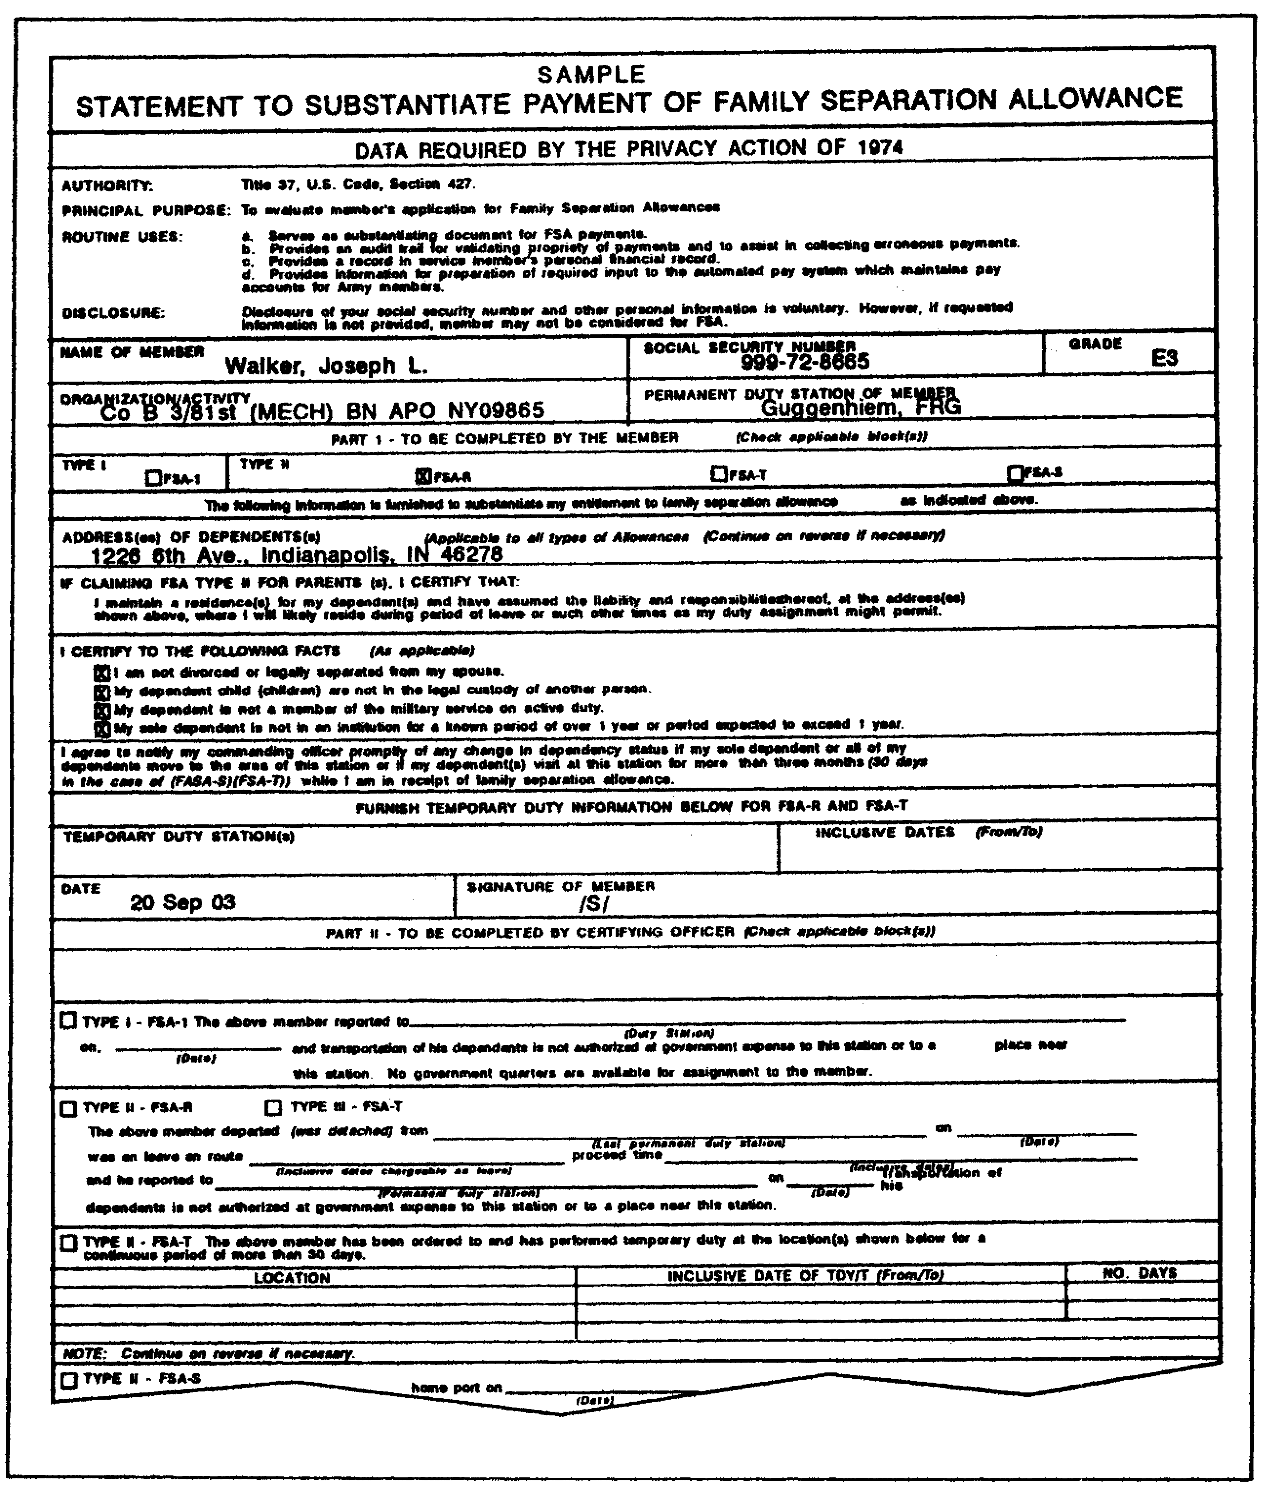

Figure 1-5. Completed DD Form 1561 (Part 1).

FI0175 1-46
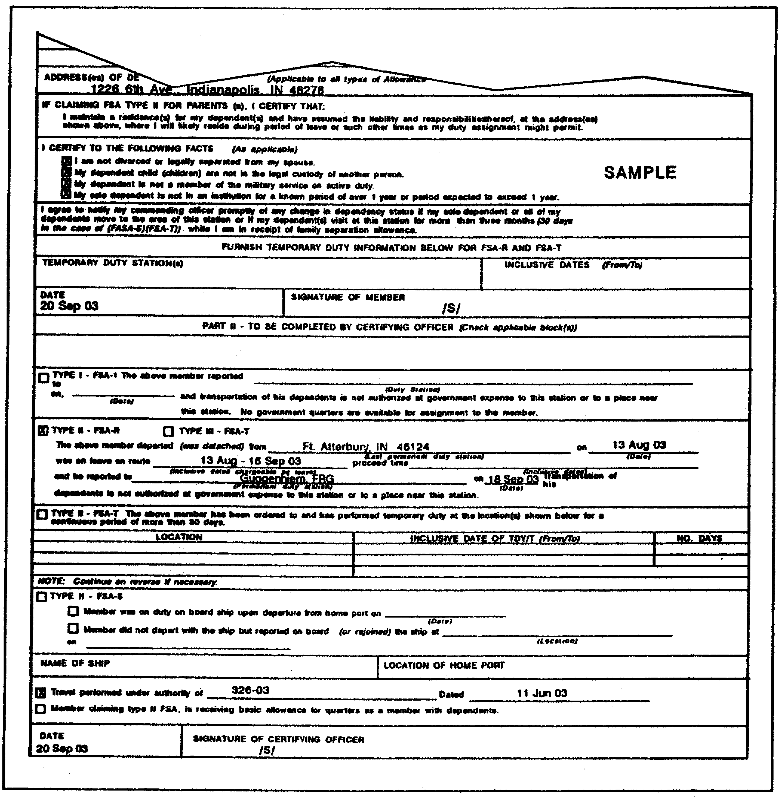

Figure 1-6. Completed DD Form 1561 (Part 2).

- A soldier with dependents is assigned to an unaccompanied tour outside the United States and for any period, while the soldier is serving that tour, his dependents live in an area of the United States which is a high-housing-cost area with respect to the soldier.

1-47 FI0175
- A soldier with dependents is assigned to a PDS in the United States. Because of the location of the PDS or circumstances of the assignment, it is necessary for the dependents to live at a different location. This area of the United States where the dependents are living is a high-housing-cost area with respect to that soldier.

- A soldier with dependents is assigned to an unaccompanied tour in Alaska or Hawaii. The soldier must be eligible to be entitled to a family separation allowance (FSA) Type I if the soldier's PDS were outside the United States. In this instance, the soldier is entitled to both of the following:

- A VHA at the rate prescribed for the PDS for a soldier without dependents.

- A VHA for dependents at a designated place in one of the other states or the District of Columbia.

The soldier must make an annual certification identifying his housing costs, otherwise he will not be entitled to the allowance. For VHA purposes, an area is considered a high-housing-cost area when the median monthly cost of housing in that area for other soldiers exceeds 80 percent of the median monthly cost of housing for soldiers in CONUS. The cost contrasts are for soldiers in the same pay grade. A soldier's old PDS is considered to be the PDS for VHA purposes through the day before the day the soldier reports at the new PDS in compliance with permanent-change-of-station (PCS) orders.

2. Definition of Variable Housing Allowance Terms.

a. Soldier With Dependents. The term "soldier with dependents," as used in Part D, means a soldier who is entitled to a BAQ at the with-dependent rate.

b. Soldier Without Dependents. The term "soldier without dependents," as used in this part of the lesson means a soldier who is entitled to a BAQ at the without-dependent rate.

c. Unaccompanied Tour. The term "unaccompanied tour," as used in this part of the lesson, means any portion of a soldier's assignment to a PDS meeting the following criteria:

- Outside the United States, when his dependents live in, or return to, the United States to establish permanent residence.

FI0175 1-48
- In Alaska, when dependents live in, or return to, one of the other states or the District of Columbia to establish a permanent residence, and the soldier is entitled to VHA for the PDS. The soldier must be entitled to FSA-I during the assignment or following departure of dependents.

- In Hawaii, when dependents live in, or return to, one of the other states or the District of Columbia to establish a permanent residence and the soldier is entitled to a VHA prescribed for the PDS. The soldier must be eligible for entitlement to FSA-I during the assignment or following departure of dependents if the PDS were outside the United States.

d. Residence. This is any quarters in which a soldier and/or dependents actually live.

e. Rental Expenses for a Residence. In the case of a soldier who rents a residence, the allowable housing expenses for the purpose of computing the VHA offset rate are limited to rent payments, and liability and personal property insurance. Also included is the standard utility/maintenance expense for the applicable location and soldier's grade (see subparagraph 2g below). For a soldier who rents a mobile home or houseboat as a residence, the allowable housing expenses also include lot or berthing fees, if applicable.

f. Ownership Expenses for a Residence. In the case of a soldier who owns a residence, the allowable housing expenses for the purpose of computing the VHA offset rate are limited to the following:

- Periodic mortgage payments.

- Hazard and liability (home owner) insurance (if not included in the mortgage payments).

- Real estate taxes.

- Personal loans unsecured by mortgages (see the fourth bullet, below).

Again, the standard utility/maintenance expense for the applicable location and soldier's pay grade is included (see subparagraph 2g below). For a soldier who owns a mobile home or houseboat as a residence, the allowable housing expenses also include lot or berthing fees, if applicable. Allowable mortgage payments (including principal, interest, taxes, and insurance (PITI), or other type loans are limited to the following:

1-49 FI0175
- Mortgages used in connection with the initial purchase of a residence.

- Mortgages used to refinance an existing mortgage which was used to purchase a residence (i.e., the existing mortgage is paid off with the proceeds from the new mortgage) to the extent the new mortgage payments do not exceed the old mortgage payments;

- Real estate equity loans (e.g., a second mortgage) when used to repair, renovate or enlarge a residence. This does not include loans used to furnish or decorate a home, or loans for personal reasons.

Example: A soldier buys a two-bedroom house near Fort Belvoir. The soldier departs Fort Belvoir on a PCS and rents the house to another person while he's gone. A few years later the soldier is reassigned to Fort Belvoir. While he's away, the soldier's family has increased by two more children. The soldier takes out a $30,000 real estate equity loan. The major portion, $20,000, of the loan is used to build an addition on the house but $10,000 will be used for college education for one of the soldier's children. That part of the loan used to build an addition ($20,000) may be used as an allowable housing expense for computing the VHA offset rate.

- Personal installment-type loans when used to repair, renovate, or enlarge the soldier's-residence. This does not include loans used to furnish or decorate a home or loans for personal reasons, or credit card or line-of-credit loans.

Example: A soldier owns a residence near Fort McPherson, GA. The roof of the house develops a leak and it is determined that a new roof and gutters are required. The house also needs painting. The soldier obtains a personal loan for $5,000. (Approximately $2,000 of this loan will be used to put a new roof and gutters on the residence, then $2,000 will be used to paint the house. The remaining $1,000 of the loan will be used to buy new tires and repaint the soldier's automobile). That part of the loan used to put on a new roof and gutters ($2,000), and to paint the soldier's house ($2,000) may be used as an allowable housing expense for computing the VHA offset rate.

g. Standard Utility/Maintenance Expense. Use a standard utility/maintenance expense for computing the VHA offset rate for

FI0175 1-50
each geographic locality, grade, and dependent status. This expense factor is based on reported utility and maintenance costs for each locality by ZIP code, pay grade, and dependent status as shown in a table prepared by the Per Diem, Travel, and Transportation Allowance Committee. A sample of the tables and multipliers is found in the extracts in appendix B of this subcourse.

h. Contingency Operation. A contingency operation is defined as a military operation designated by the Secretary of Defense meeting one or more of the following criteria:

- An operation in which members of the armed forces are or may be involved in military actions, operations, or hostilities against an enemy of the United States, or against an opposing force.

- An operation which results in the call or order to, or retention on, active duty of members of the uniformed services under any provision of law declaring a war, or during a national emergency declared by the President or Congress.

3. Rates Payable.

a. General. The VHA is a percentage of a soldier's BAQ and is payable to a soldier with or without dependents at an offset rate as prescribed by the following:

- JFTR.
- Rate tables prepared by the Per Diem, Travel and Transportation Allowance Committee.
- The SECDEF in a special determination.

VHA is not payable for the number of travel days allowed for direct travel between the old and new permanent duty station (PDS) incident to a PCS. Make the reduction in the VHA entitlement for those travel days at the soldier's rate while assigned to the old PDS. Use the rate payable following departure from that PDS if an allowance was not paid while at the PDS because government quarters were assigned.

b. VHA Offset. When the soldier's prescribed VHA plus BAQ exceeds his rental or ownership expenses, compute the VHA payable at an offset basis, as will be explained subsequently. The amount of the reduction (of the amount payable to the soldier) will not exceed the soldier's prescribed VHA. If the soldier's housing costs equal or exceed the total of his prescribed VHA plus BAQ, he is entitled to the full VHA without offset.

1-51 FI0175
Example: SGT Reardon and his non-service wife rent an apartment near his duty station for $525.00 per month. SGT Reardon is entitled to BAQ at the with-dependent rate in the amount of $376.20 (DODPM table 3-2-9). His ZIP code is 42622 which places him in VHA table 94 (appendix B). The multiplier for an E-5 is .12618 X his BAQ entitlement ($376.20) or $47.47. This gross VHA rate of $47.47 is added to his BAQ entitlement and equals $423.67. SGT Reardon's utility rate is computed by multiplying his BAQ entitlement by the utility multiplier found in table 94: .49121 X the w/o multiplier of .87 = $160.77. This figure is added to his monthly rental of $525.00 for total expenses of $685.77. Compare that figure to total allowances of $423.67 and you can stop right there. He receives his full VHA entitlement. There is no VHA offset applicable. (Subsequent examples will illustrate the VHA offset calculations.)

c. Applicability of VHA Offset. The offset method of computing VHA becomes effective when a soldier and/or dependent occupy a permanent residence, or 60 days after the soldier's arrival at the PDS, whichever occurs first. Offset provisions 42 do not apply to the following soldiers:

- Soldiers in transit between PDSs who are otherwise entitled to VHA.

- Those living in temporary quarters upon arrival at a new PDS (not to exceed 60 days).

- Soldiers living in temporary quarters before leaving an old PDS (not to exceed 60 days).

d. Soldier Without Dependents. Use the VHA prescribed for the soldier's PDS to determine the entitlement for a soldier without dependents.

e. Soldier With Dependents. Use the VHA prescribed for a soldier's PDS to determine a soldier's entitlement for a soldier with dependents whether the dependents live with the soldier or at a different location. When the dependents live separately from the soldier, and the soldier is assigned to an unaccompanied tour at a PDS, use the following criteria:

- Outside the United States, the allowance prescribed for the area within the United States where the dependents live is used to determine the soldier's entitlement for VHA for the dependents.

FI0175 1-52
- In Alaska or Hawaii, use the allowance prescribed for the area within the other state or District of Columbia where the dependents live to determine the soldier's entitlement to VHA for dependents.

- In Alaska or Hawaii, use the allowance for the area within Alaska or Hawaii where the dependents live to determine the soldier's allowance to VHA when both the PDS and the dependent's residents are in the same state. This applies when the soldier in Alaska is entitled to FSA Type I or the soldier in Hawaii would be entitled to FSA Type I if the PDS were outside the United States.

In situations where the soldier's dependents live in multiple locations, the soldier designates the primary residence of dependents for VHA entitlement.

f. Both Husband and Wife are Members of the Armed Forces. When both husband and wife are members of the Armed Forces, each is entitled to a VHA as a member, with or without dependents as applicable, depending on whether the member has a dependent other than the spouse. This entitlement exists whether husband and wife maintain a joint residence or separate residences. In no case will a spouse who is also a member on active duty be considered as a dependent for entitlement purposes.

g. Soldier in Leave Status Awaiting Final Discharge. A soldier in a leave status away from his PDS while awaiting final discharge is entitled to the same VHA as he would be paid if the leave was taken at his PDS.

4. Establishment of VHA.

VHA rates are based on military housing areas (MHAs) established by the Per Diem, Travel, and Transportation Allowance Committee. The committee collected and analyzed housing cost data throughout CONUS. Each MHA contains multipliers directly associated with pay grades including E-1 with less than four months service and officers through major with prior enlisted service. These multipliers are a percentage of the soldier's BAQ. Every valid ZIP code in CONUS is associated with a MHA. A VHA ZIP code and rate table microfiche are provided to FAOs on a monthly basis.

To compute the VHA you multiply the soldier's BAQ by the appropriate multiplier from the MHA rate table for his or her pay grade. Base the computation on a 30-day month, the same as BAQ. There is only one multiplier for each pay grade. In some cases, the multiplier may be "0" for a particular grade, in which case no VHA is payable. The multipliers are subject to change due to periodic reviews of housing costs in the various designated MHAs.

1-53 FI0175
Refer to appendix B at the end of this subcourse for extracts from the VHA Military Housing Areas Table and associated multipliers for the different pay grades.

Since 1985 VHA computation has changed for single soldiers receiving BAQ at the with-dependent rate based on court-ordered or voluntary child support payments. The change requires payment of BAQ at the with-dependent rate, but payment of VHA is to be paid using the without-dependent rate.

Also in 1985, VHA replaced the overseas housing allowance (OHA) for soldiers in Alaska and Hawaii. A new allowance, VHA-2, is now used to pay soldiers without-dependent VHA when they are on an unaccompanied tour in Alaska or Hawaii (see subparagraph 41(2)).

The Authorization Act of 1986 provided a new computing methodology for VHA by relating housing allowances to housing expenses paid (VHA-offset). The soldier's actual rent or mortgage amount paid for VHA or VHA-2 is input to the MMPA with a share indicator code when there are multiple inhabitants or roommates. In addition, VHA rate tables containing utility multipliers by pay grades for BAQ (with and without dependents) are also used in the VHA computation. VHA offset does not apply to soldiers who are TDY en route to a permanent duty station (PDS).

a. Nonentitlement to VHA. Soldiers are not entitled to VHA for the number of authorized travel days while on a PCS move.

Soldiers making child support (voluntary or court-ordered) payments are also not entitled to VHA when assigned to single-type government quarters and not having custody of illegitimate children. Soldiers assigned outside the continental United States (OCONUS) who receive BAQ at the with-dependent rate because of child support and are authorized station housing allowance are not entitled to VHA.

b. Voluntary and Court-ordered Child Support. A soldier is entitled to VHA if he lives off-post and receives BAQ (with dependent rate), based on voluntary or court-ordered support of dependents.

If a soldier in pay grade E-7 or above lives off-post and receives BAQ (with-dependent rate) based on child-support payments, VHA is payable at the without-dependent rate. If a soldier in pay grade E-6 or lower lives off post with a statement of nonavailability (of government housing) issued by the housing office or DA Form 4187 from his unit commander and receives BAQ (with-dependent rate) based on child-support payments, VSA is also payable at the without-dependents rate.

FI0175 1-54
If the soldier does not have a statement of nonavailability or a DA Form 4187 from his unit commander, then VHA is not payable. You must coordinate with the local housing offices and commanders to ensure that soldiers in pay grades below E-7 who leave government quarters obtain a statement of nonavailability from the housing office in order to receive VHA.

When soldiers below pay grade E-7 move from off post to government quarters, the unit commander must provide the FAO with DA Form 4187 so VHA can be terminated. Soldiers living on the overseas economy, regardless of whether or not the child support is court-ordered or voluntary, are not entitled to VHA. Soldiers living in single-type government quarters who have legal custody of an illegitimate Child or children are entitled to VHA at the with-dependents rate.

Soldiers living off post who do not have legal custody of illegitimate children are paid VHA at the without-dependent rate. There is a savings clause for soldiers living off post and receiving BAQ (with-dependent rate) and VHA based on child-support as of 30 September 1985. These soldiers are entitled to VHA (with-dependent rate) until their next PCS move.

c. Dependents Arrive at Overseas Station After Soldier. In instances when dependents arrive at or in the vicinity of a soldier's OCONUS PDS after the soldier and remain in excess of 30 days, entitlement to VHA ends on the day prior to the day that one or more dependents arrive at the overseas location.

d. Early Return of Dependents from OCONUS. Soldiers who have all of their dependents return to CONUS before completion of an accompanied tour are entitled to VHA on behalf of the dependents. The only requirement is that the dependents return to CONUS and establish a permanent residence. Permanent residence for VHA purposes is defined as wherever the dependents are living in CONUS. In the case of multiple residences or locations of the dependents, the soldier designates the location on which to base VHA payments. The effective date of VHA entitlement begins on the day one or more dependents arrive at their CONUS residence, or the day all dependents depart the soldier's overseas duty station, whichever is later. DA Form 4187 is prepared and sent through the soldier's unit commander (this applies only to pay grades below E-7). The form provides the name and arrival date of the first dependent to leave the overseas duty station at the OCONUS residence, the name and departure date of the last dependent from the overseas duty station, and the ZIP code of the CONUS residence.

1-55 FI0175
e. VHA Entitlement for Reservists.

(1) Called (or Ordered) to Active Duty for More Than 20 Weeks. Except as provided in paragraphs (2) and (4) below, payment of VHA for reserve component (RC) soldiers ordered to active duty for more than 20 weeks is computed based on the location from which they are ordered to active duty, beginning on the day they are entitled to BAQ. The initial rate terminates on the day prior to the date the soldier reports to the duty location prescribed in the active duty orders. Entitlement to VHA at the rate prescribed for the duty location begins on the day the soldier reports at that location. Reduce the soldier's VHA entitlement at the PDS rate by the number of allowable travel days for direct travel to and from the active duty location.

Example: Reserve SSG Goodman is called to active duty for one year on orders dated 9 September 2003. SSG Goodman leaves his home in Sandusky, Ohio on 10 September and reports to his PDS on 13 September. SSG Goodman's BAQ and VHA accrues from 10 September. The VHA is computed at the rate applicable at his home in Sandusky, Ohio from 10 September through 12 September. From 13 September onward, his VHA is computed at the rate applicable at the duty station. The travel days are deducted from his VHA entitlement at the PDS rate.

(2) Called or Ordered to Active Duty for 20 Weeks or More But Not Authorized Transportation of Household Goods. Except as provided in paragraph (4) below, an RC soldier called or ordered to active duty (other than for training) for 20 weeks or more at a place away from his or her home (at the time called or ordered to active duty) is considered to be assigned to duty at that residence. He is paid the VHA at the rate for that location if he is not authorized transportation of HHG from home to the duty station. Entitlement to VHA begins on the day the soldier is entitled to BAQ. Reduce the soldier's VHA entitlement by the number of allowable travel days to and from the active duty location.

Example: Reserve MAJ Hearst is ordered to active duty for a two-year period on orders dated 10 September 2003, and transportation of HHG is not authorized. He leaves his home in San Diego, California 11 September and reports for duty at Fort Benning, Georgia 12 September. MAJ Hearst's BAQ and VHA accrue from 11 September. His VHA is computed at the rate applicable at his residence in San Diego for the duration of his entitlement. The travel day is deducted at the rate applicable at his San Diego home.

FI0175 1-56
(3) Called or Ordered to Active Duty for Less Than 20 Weeks.
Except as provided in paragraph (4) below, RC soldiers called or ordered
to active duty for less than 20 weeks are not entitled to VHA unless the
call is in support of a contingency operation as defined previously in
paragraph 2h. Any soldier called to active duty in support of a
contingency operation is entitled to VHA at the rate prescribed for his
principal residence at the time he was called to active duty.

(4) Reserve and Retired Soldiers Called to Active Duty in Connection With the Persian Gulf Conflict. Any reserve or retired soldiers called or ordered to active duty (other than for training) in connection with the Persian Gulf conflict were entitled to a VHA regardless of the duration of the call-up. All soldiers covered under this paragraph were subject to the VHA offset for their entire period of active duty. However, VHA entitlement under this paragraph was not reduced by allowable travel days. (The term "Persian Gulf conflict" means the period beginning on August 2, 1990 and ending thereafter on the date prescribed by presidential proclamation or by law. It included participation in operations known as Operation Desert Shield and Operation Desert Storm.)

f. New Arrivals. Newly inducted, enlisted, or reenlisted soldiers, officers, and officer candidates are entitled to VHA at the rate prescribed for the location of their principal residence at the time they are ordered to active duty. Entitlement begins on the day they are entitled to BAQ at the without-dependents rate. For soldiers with dependents, use the rate applicable to the location of the dependents' residence. In instances where the dependents live outside CONUS (OCONUS), other than Alaska and Hawaii, the rate is determined in the same manner as for soldiers without dependents, i.e., the dependents' residence.

g. Dependent-location-based VHA Payment. Sometimes the location of the dependent rather than the duty station determines the rate of VHA entitlement. The intent is to relieve inequities caused by payment of VHA based on the duty station when it is necessary for the dependents to live separately, even though the soldier is assigned in CONUS. There is no intent to provide relief when the reason for separation is a personal choice of the soldier or his dependents.

Most situations within the Army involve unit activations, deactivations, or relocations where there is a shortage of available housing.

1-57 FI0175
Two types of application procedures are used. In situations where entire units are affected, unit commanders normally request a delegation of authority from the Assistant Secretary of the Army (Manpower and Reserve Affairs)(ASA(M&RA)) through command channels to approve their soldiers' applications at unit level. In situations where only the individual soldier is affected, he applies to ASA(M&RA) individually for approval. Soldiers can apply on any situation, not just housing availability. However, the above criteria of not justifying personal choice remains the same.

The request must contain a description of the inequity placed on their soldiers, relief measures being pursued (such as housing construction forecasts for both on- and off-post housing), and the potential number of soldiers affected.

h. JUMPS Substantiating Documents for VHA. Entitlement of VHA is dependent on the soldier's entitlement to BAQ and begins and ends under the same conditions. Use DA Form 5960 (fig. 1-3) to substantiate entitlement to VHA. Copies of housing expenses are attached to the DA Form 5960. As noted earlier, RC component entitlement is contingent on both BAQ entitlement and the length of their active duty tours.

i. Processing VHA Requests. Soldiers covered by a unit waiver submit their request on DA Form 5960. After the request is approved the DA Form 5960 is submitted to the FAO.

DA Form 5960 is prepared for newly assigned personnel during in-processing by the in-processing clerk when the soldier has the appropriate documentation. The original is retained by the FAO, a copy is sent to the soldier's unit commander, and one is given to the soldier.

Entitlement to VHA continues at the old-station rate prior to arrival at the new station. Since VHA changes are made during in-processing, there is no need for soldiers who are pending assignment to a unit with approved delegation to apply before arrival at the new station.

The effective date of VHA payments based on the dependent's location is the date approved by the commander within the delegation received from ASA(M&RA).

Applications from individual soldiers arising from situations other than unit-wide circumstances are also submitted on DA Form 5960 through command channels to HQDA.

Basic entitlement to VHA is still based on the ZIP code of the soldier's duty station when assigned to CONUS. Only upon approval of a request

FI0175 1-58
under the authority of ASA(M&RA) can VHA be based on the ZIP code of the dependent.

j. Use of ZIP Codes. Every valid ZIP code is associated with a military housing area (MHA). Use the ZIP code of the soldier's duty station or the dependent's residence, if the soldier is serving overseas on an unaccompanied or all others tour, to input authorization for payment of VHA. Invalid ZIP codes will cause the input entry to be rejected.

k. Computing VHA Entitlements.

(1) Arrival at a New PDS. Upon arrival at a new PDS or residence of dependents a soldier is authorized VHA without offset until such time as a permanent residence is occupied or 60 days after arrival, whichever occurs first.

(2) Computing VHA Offset Rates. When the soldier occupies a permanent residence, or beginning on the 61st day after reporting for duty, the soldier reports the actual rental or ownership expenses to the FAO. This amount does not include the standard utility/maintenance expense. If the soldier's rental or ownership expenses, as earlier defined, are less than the sum of the prescribed VHA and his BAQ, reduce his prescribed VHA by 50 percent of the difference between the rental or ownership expense and the sum of his prescribed VHA plus BAQ. In no event will the amount of the reduction exceed the soldier's prescribed VHA. When the soldier's rental or ownership expenses are equal to or more than the total of the soldier's prescribed VHA plus BAQ, pay him the full prescribed VHA.

l. Adjustments to VHA Entitlements.

(1) Rate Tables. Each month FAOs receive two sets of microfiche. The first set is the VHA rate tables which contain multipliers and utility multipliers by pay grade for with and without dependents. The second is a list of every valid ZIP code in the MMPA and the VHA rate table associated with the ZIP code. Extracts of the VHA tables are found in appendix B at the end of this subcourse. Use the rate tables to compute VHA entitlements.

Compute them as in the following examples. All situations are hypothetical.

Situation: A 1LT living off-post receiving BAQ (with-dependent rate) for child support is assigned to Fort Atterbury, Indiana. Assume a ZIP code of 46224 and a VHA table of 094. The multiplier for a 1LT is 0.15034 and the BAQ entitlement is $344.40 (the without-dependent rate is used for the VHA computation). The VHA entitlement is $51.78 (gross VHA entitlement).

1-59 FI0175
Multiply:

BAQ rate (without-deps) $344.40
Multiplier X 0.15034
VHA due soldier $51.78

The amount of rent paid is $250.00, the with-dependent utility multiplier derived from the rate table is 0.33780 and the without-dependent multiplier is 1.00000.

The utility rate is calculated by multiplying the BAQ (without-dependents rate) $344.40 times 0.33780 (with-dependents multiplier), and then multiplying that result by 1.0000 BAQ (without-dependent multiplier), which equals $116.34. Add the housing allowances (gross VHA and BAQ rates), then add the housing expenses (rent paid and utility rate).

Compare the two subtotals ($51.78 + $344.40 = $396.18 for housing allowances and $250.00 + $116.34 = $366.34 for housing expenses) which results in a grand subtotal of $29.84 ($396.18 -$366.34).

In this case, the soldier is receiving $29.84 more per month in housing allowances than that incurred for housing expenses. To arrive at the VHA offset divide the grand subtotal of $29.84 by 2 = $14.92 (VHA offset). Subtract the VHA offset ($14.92) from the gross VHA rate ($51.78) for a net amount of $36.86 due the soldier.

The net amount ($36.86) appears in the entitlements block of the soldier's leave and earning statement (LES) and the VHA offset appears in the REMARKS section of the LES.

Add housing allowances –-

Gross VHA rate $51.78
BAQ rate (without-deps) + 344.40
Subtotal $396.18

Add housing expenses --

Rent paid $250.00
Utility rate +116.34 *
Subtotal $366.34

*Computation ($344.40 X 0.33780 X 1.0000).

Comparison --

Subtotal for allowances $396.18
Subtotal for expenses -366.34
Grand subtotal (VHA offset) $ 29.84

FI0175 1-60
Gross VHA rate $51.78
VHA offset -14.92 *
Net VHA due soldier (block 6 of LES) $36.86

*Computation (grand total: 29.84 divided by 2 = 14.92).

Using the same example as before, all factors are the same except the soldier is married, the gross VHA rate is $196.68 and BAQ entitlement at the with-dependent rate is $440.10.

Add housing allowances --

Gross VHA rate $196.68
BAQ rate (with deps) +440.10
Subtotal $636.78

Add housing expenses --

Rent paid $250.00
Utility rate +148.47 *
Subtotal $398.67

*Computation ($440.10 X 0.33780)

Comparison --

Subtotal for allowances $636.78
Subtotal for expenses -398.67
Grand subtotal (VHA offset) $238.11

(VHA offset) $238.11

Gross VHA rate $196.68
VHA offset -119.06
Net amount of VHA due soldier $ 77.62

*Computation ($238.11 divided by 2)

Never is the VHA rate to be reduced to the point where BAQ is collected from a soldier. The soldier would not receive a VHA entitlement, but he would be paid BAQ. A hypothetical example of this situation follows.

Example:

Add housing allowances --

Gross VHA rate $ 10.00
BAQ rate (without deps) +344.40
Subtotal $354.40

1-61 FI0175
Rent paid $150.00
Utility rate -116.34
Subtotal $ 33.66

Comparison --

Subtotal for allowances $354.40
Subtotal for expenses - 33.66
(VHA offset) $320.74 *

*Grand subtotal divided by 2 = $160.37

Since the VHA offset ($160.37) is greater than the gross VHA rate, the VHA offset is defaulted to $10.00 and no VHA is paid to the soldier.

No JSD is required to be sent to DFAS-IN for payment of VHA for PCS. The original travel voucher is routinely sent to DFAS-IN for substantiation of the travel payment. Use this to verify payment of VHA.

(2) Dual Payment of VHA. Soldiers may be entitled to dual VHA payments. When a soldier is assigned to an unaccompanied tour in Alaska or Hawaii and his dependents remain in one of the other 48 contiguous states or the District of Columbia, the soldier may receive VHA for the dependents' location. VHA is at the with-dependents rate. Additionally, the soldier may be entitled to VHA 2 prescribed for a soldier without dependents at his new permanent station in Alaska or Hawaii. VHA 2 is used exclusively for the soldier's housing allowance and is found in the ENTITLEMENTS block of the LES. The REMARKS section will show each distinct location code. For example, a soldier is assigned to Fairbanks, Alaska and his dependents are in Indianapolis, Indiana. The REMARKS on that soldier's LES would be –-

"VHA COMPUTED BASED ON ZIP CODE 46216"
"VHA 2 COMPUTED BASED ON ZIP CODE 99701"

(3) Dual VHA Payments. Soldiers may be entitled to payment of more than one station allowance under provisions of the JFTR. Only two such payments are payable at any one time.

FI0175 1-62
LESSON

PRACTICE EXERCISE

The following items will test your understanding of the material covered in this lesson. There is only one correct answer for each item. When you complete the exercise, check your answers with the answer key that follows. If you answer any item incorrectly, study again that part of the lesson which contains the material involved.

Note: This exercise is designed to approximate, as closely as possible, the actual conditions you will be working under in the military pay branch. To answer the questions, you will be required to refer to the extracts in the appendix to determine entitlement and allowance rates and amounts.

Situation: Assume that you are an NCO in the 76th Finance Support Unit (FSU), Fort Atterbury, Indiana. You will be called upon to determine allowance entitlements, compute the amounts due to individual soldiers, and answer their questions concerning entitlement to certain allowances. Government-furnished living and dining facilities are available at Fort Atterbury. Today's date is 23 July 2003. Use this general situation and the following specific situations to answer the questions in this exercise.

1. CPL Higgins comes in to the finance office to inquire about BAS while he is on a two-week temporary duty assignment. He is currently entitled to BAS at the separate-rations rate and wants to know if he will lose his entitlement during the TDY period. You reply,

A. "yes, you will lose BAS entitlement for the TDY period."
B. "you will receive your BAS at the rations-not-available rate."
C. "you will be entitled to BAS only during travel periods, if you are entitled to per diem and mileage."
D. "your separate rations entitlement will continue uninterrupted."

1-63 FI0175
Situation: SGT Whitten is a military policemen and his mission requires him to be on duty in the downtown area from 1800 to 0200 nightly. He must take his supper when conditions permit at whatever restaurant is available. The Secretary of the Army has made no determination of his situation, but his commander has approved his working conditions. This situation will exist for two months. (Assume a five-day work week and five weeks in the month, and four years active service.) Use this situation to answer question 2.

2. What do you determine SGT Whitten's monthly BAS entitlement to be?

A. $69.75.
B. $134.00.
C. $160.80.
D. $208.20.

Situation: CPL Clark is currently housed in government-furnished housing. But, he has decided to bring his wife and child to his permanent duty station and move into family-type housing. Thus, he will be entitled to mess separately. Use this situation to answer question 3.

3. What JUMPS-Army substantiating document authorizes you to make separate rations payable to CPL Clark?

A. DD Form 137.
B. DA Form 4187.
C. DA Form 3298.
D. DA Form 5545.

Situation: SFC Glass is a soldier without dependents who is assigned to field duty, and thus, is not entitled to basic allowance for quarters (BAQ). But he is entitled to partial BAQ. Use this situation to answer question 4.

4. What do you determine SFC Glass' entitlement to be?

A. $435.40.
B. $302.40.
C. $12.00.
D. $9.90.

FI0175 1-64
Situation: SPC Greer is married and currently drawing BAQ at the with-dependent rate. However, during July he was in excess leave status for five days. Use this situation and the extracts of the DODPM to answer question 5.

5. To how much, if any, BAQ do you determine SPC Greer is entitled for the month of July?

A. None, BAQ does not accrue to soldiers in excess leave status,
B. $272.75.
C. $36.60.
D. $219.60.

Situation: Assume that you are preparing a claim for BAQ entitlement in behalf of a soldier's unmarried illegitimate child. The determination of entitlement will be made by DFAS-IN. Use this situation to answer question 6.

6. You prepare the claim on a

A. DD Form 137.
B. DA Form 4187.
C. transmittal letter.
D. DA Form 3298.

Situation: SGT Magruder receives his overseas PCS assignment to an area where concurrent travel is automatically authorized but leaves his family behind. He has elected to serve the "all others" tour because he fears for his family's safety overseas. After arrival at his overseas station and entitlement to FSA-1, SGT Magruder finds conditions vastly different than he previously imagined, and his dependents express their desire to reunite the family. SGT Magruder changes his election to a "with command sponsored dependents" tour and the change is approved. Use this situation to answer question 7.

7. What, if any, FSA entitlement do you determine exists?

A. SGT Magruder's FSA entitlement continues through the day before the tour change is approved.
B. SGT Magruder's entitlement continues through the day before his dependents arrive at his station.
C. FSA-1 continues, uninterrupted, through SGT Magruder's overseas tour of duty.
D. SGT Magruder's FSA entitlement halts on and after the day his dependents depart the continental U.S.

1-65 FI0175
Situation: PFC Gonzales is serving an unaccompanied tour of duty in Alaska. He has a wife and child who are living near his old duty station in Georgia. PFC Gonzales is entitled to BAQ and would be entitled to FSA Type I if his permanent station was OCONUS. Use this situation to answer question 8.

8. What, if any, do you determine his VHA entitlement to be?

A. None; VHA entitlement does not exist for soldiers stationed in Alaska and Hawaii.
B. A VHA for his dependents in Georgia.
C. None; if FAS Type I is not payable, VHA is not payable.
D. A VHA-2 at the without-dependents rate prescribed for his PDS and VHA for his dependents in Georgia.

Situation: You are computing July VHA entitlement for SFC Beckwith. The soldier's documents tell you his ZIP code is 46241, he is basing his claim on his permanent duty station, he has no dependents, and his rent is $250.00 per month. Use this situation to answer questions 9 and 10.

9. What amount do you compute as his VHA entitlement for July?

A. $52.85.
B. $47.29.
C. $44.63.
D. $40.07.

10. The form which gave you the information referred to in question 9 is also the JSD for VHA entitlement. What is it?

A. DD Form 3298.
B. DA Form 5960.
C. DD Form 137.
D. The leave and earnings statement.

FI0175 1-66
LESSON

PRACTICE EXERCISE

ANSWER KEY AND FEEDBACK

Item Correct Answer and Feedback

1. D. "your separate rations entitlement will continue uninterrupted.

Enlisted soldiers on authorized leave, hospitalized, on TDY, TAD, or PCS are normally entitled to BAS at the separate-rations rate. That entitlement exists for the duration of the soldier's travel status regardless of the BAS rate authorized at his permanent station. However, if the TDY station is authorized the emergency rations rate, the soldier may be entitled to the higher rate. (page 1-2, para la and DODPM Table 3-1-5, Rule 1.)

2. A. $69.75.

Since SGT Whitten must take his evening meal downtown whenever and wherever conditions permit, it is obvious government "rations" are "not available" and BAS at the RNA rate would be applicable (page 1-6, para 2c(2). The authorization could have come from the Secretary of the Army because the soldier's mission creates the condition, but the situation more closely falls under para 3d on page 1-8 (DODPM Table 3-1-4, Rule 6). The unit commander makes the determination when impractical location or duty requirements prevent use of a government mess. Since only the evening meal is involved it is obvious the entitlement will be prorated. The proration tables in para 6b(2)(b) on page 1-11 shows the RNA rate of $2.79 for lunch and dinner for E-1 through E-9 with 4 months or more active duty. $2.79 X 5 days is $13.95 per week X 5 weeks equals $69.75.

1-67 FI0175
Item Correct Answer and Feedback

3. B. DA Form 4187.

Upon his eligibility to separate rations, CPL Clark's commander will send you a completed DA Form 4187, Personnel Action, showing the date and time of the soldier's entitlement to BAS. DA Form 4187 is applicable only to separate rations. Separate rations on a prorated basis is always substantiated by DD Form 1475, Basic Allowance for Subsistence-Certification. You will also need a signed statement from the soldier residing with his dependents in an original and two copies. The original is the JSD. One copy goes with the soldier, the other is sent to his commander. (page 1-12, para 8a)

4. C. $12.00.

Soldiers without dependents assigned to single-type government quarters or field duty are not entitled to BAQ, but they are entitled to partial BAQ at the rates specified in Table 3-2-9 in the extracts of the DODPM in the appendix. The table shows the monthly rate applicable for a SFC (E-7) to be $12.00. (page 1-17, para la & DODPM Table 3-2-9)

5. B. $272.75.

Soldiers in excess leave status do not accrue BAQ during the entire period they are in that status. A SPC is entitled to $327.30 per month at the with-dependent rate. That amount divided by 30 is $10.91 per day times five (days excess leave) equals $54.55 from $327.30 equals $272.75 due SPC Greer for July. (DODPM Table 3-2-3, Rule 10 & Table 3-2-9)

6. A. DD Form 137.

The DD Form 137 is used only when the claim is submitted to DFAS-IN. With your assistance, the soldier enters the required information in the blocks provided. If the claim involves a claim on behalf of an illegitimate child, have the soldier fill out the form in the original and one copy; otherwise submit only the original. If the claim is approved by DFAS-IN, the form becomes the JUMPS substantiating document. (page 1-30, para 9e(2))

FI0175 1-68
Item Correct Answer and Feedback

7. B. SGT Magruder's entitlement continues through the day before his dependents arrive at his station.

Under Rule 3 of the DODPM Table 3-3-1, if the soldier's overseas PCS assignment is to an area where concurrent travel is automatically authorized, but the soldier elects to serve an "all others" tour, his entitlement to FSA starts when he leaves his family behind in the U.S. If he later elects to change the tour to an "accompanied" tour and the change is approved, his FSA continues through the day before his family arrives at the overseas station. Note 1 does not apply in this case since the family is no longer separated and the allowance stops when his dependents arrive at the overseas station. Entitlement to FSA will not exceed 60 days from the date transportation of the dependents is authorized, unless additional delay is caused by the government. (DODPM Table 3-3-1, Rule 3)

8. D. A VHA-2 at the without-dependents rate prescribed for his PDS and VHA for his dependents in Georgia.

Since assignment to a permanent duty station in Alaska or Hawaii is similar to PCS overseas in most respects, provision is made for soldiers so assigned. Soldiers serving an unaccompanied tour in Hawaii or Alaska who would be entitled to FSA Type I if their assignments were overseas are entitled not only to VHA-2 at the without-dependents rate locally applicable (in Alaska or Hawaii), but to a VHA for their dependents at the with-dependent rate applicable at their place of residence, in this example, Georgia. (page 1-48, para 1)

1-69 FI0175
Item Correct Answer and Feedback

9. A. $52.85.

Basically, as you learned at the beginning of paragraph 4, the VHA is computed by multiplying the soldier's BAQ times the appropriate multiplier from the MHA rate table for his or her pay grade. Since 1986, adjustments involving actual housing expenses and allowances have come into the computation of VHA (VHA offset). If you add the soldier's gross VHA rate, which is determined by multiplying his without-dependent BAQ rate ($314.70) by the multiplier in table 94 in the extracts (0.16793) you obtain $52.85. Continuing the VHA adjustments, you add BAQ and gross VHA ($314.70 + $52.85) and arrive at $367.55. Adding the housing expenses of $250.00 and utility rate ($314.70 times the with-dependent multiplier in the VHA table [0.52271], times the W/O multiplier (0.8700] and you get $143.11). Housing expenses total $393.11 while housing allowances total only $367.55. Subtracting expenses from allowances would result in a negative figure. In this case the VHA offset is defaulted and the soldier is paid his gross VHA. (page 1-51, para 3b)

10. B. DA Form 5960.

The JUMPS substantiating document is DA Form 5960, Authorization to Start, Stop, or Change BAQ and/or VHA. DA Form 5960 will furnish all the information necessary to determine entitlement and compute the allowance. VHA entitlement is dependent on BAQ entitlement and is started and terminated under the same conditions. (page 1-58, para 3h)

FI0175 1-70

